Superset Table of Contents

Logging In

Adding Users

Granting Access to a Datasource

Adding a Datasource to a Role

Add a Role to a User

Accessing a Datasource

Uploading a CSV

Review and Edit a Table

Table actions

Edit a table

Charts

The chart UI

Visualization type

Bar chart

Styling

Time series - bar chart

Define a temporal data field/column

Styling

Pie chart

Styling

Line chart

Styling

Big number

Table chart

Sample table

Styling

Pivot table

Country map

Deck.gl scatter plot

Save a chart

Dashboard

Creating your dashboard

Tabs

Row/Column

Adding charts

Headers

Dividers

Delete a dashboard component

Save the dashboard

Add/Edit Dashboard Filters

Filter Settings and Scoping

Dashboard actions

Dashboard properties

Additional features

Choose the color for a variable

SQL Lab

Table schema

Custom SQL Query

Adding a Query

Superset

With Superset, users can draw insights from data gathered within their organizations and from external sources to review historical trends and make informed decisions.

## Logging In

To log in, you will want to:

1. Access Superset via the link <https://inform.discover.ona.io/>.
2. Select **Login** on the upper right-hand corner of the page as shown below.



1. On the **Sign In** page, submit your account credentials and click **Sign In**.

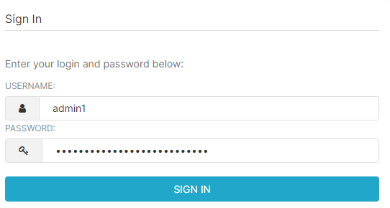

1. Once you have successfully logged in, the home page will appear with different sections as shown below.

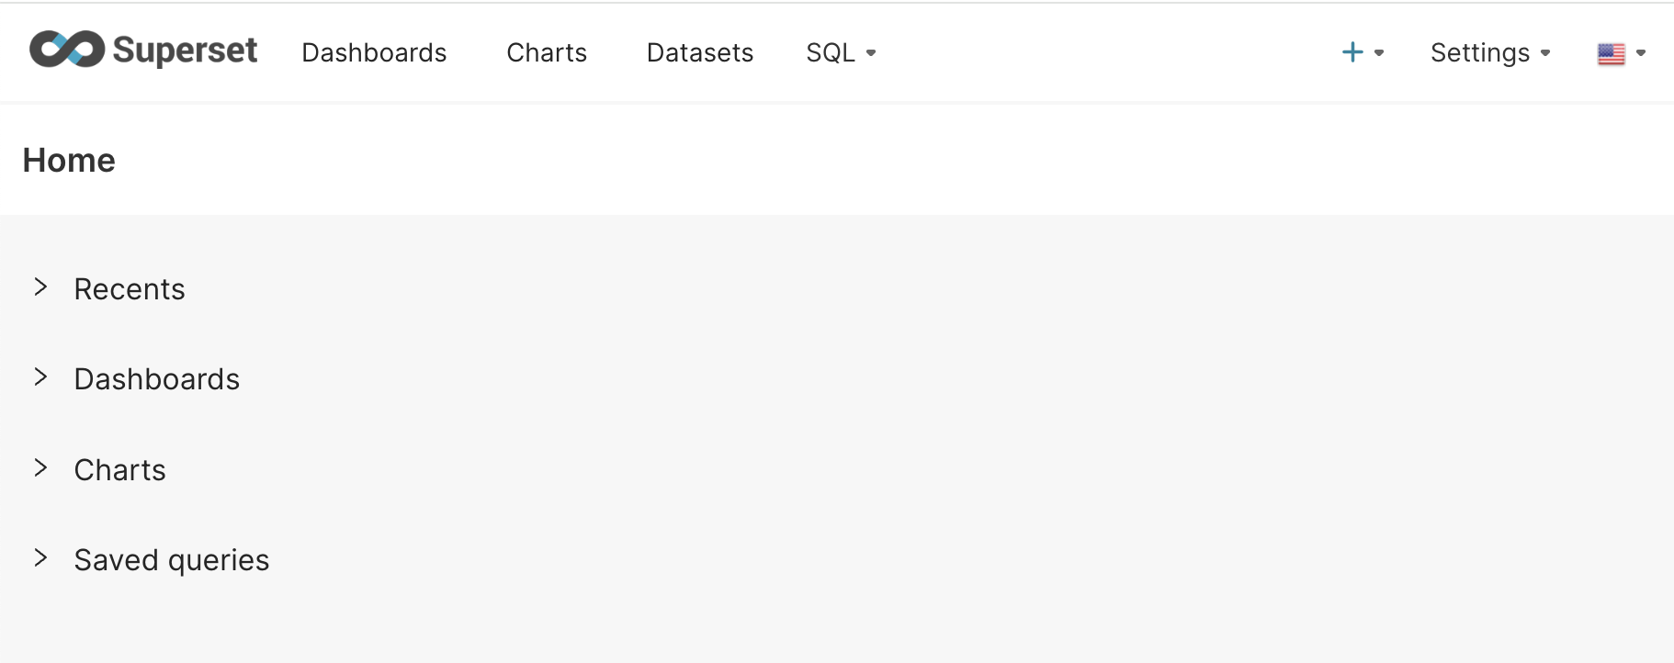

**NOTE:** The initial appearance of the home page will depend on the permissions given to your account.

## Adding Users

Only an admin can add users to the instance. To add a user, you will want to:

1. Hover over **Settings** and click on **List Users.**

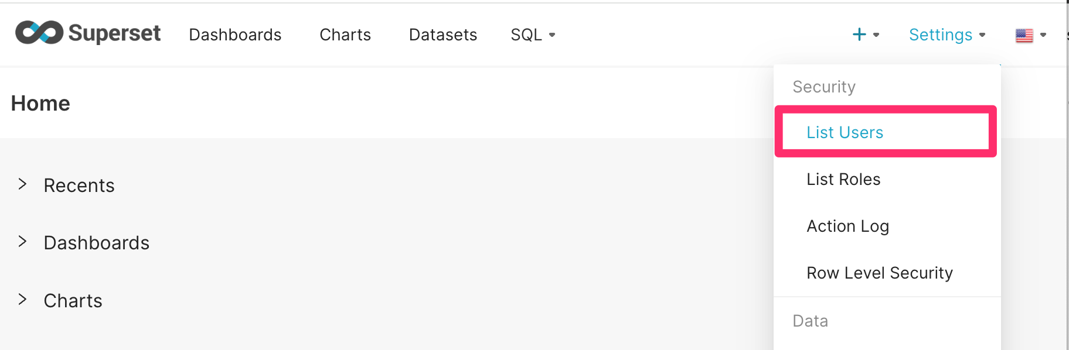

1. On the **List of Users** page, click the **plus sign (+)** to add a new record as shown below.

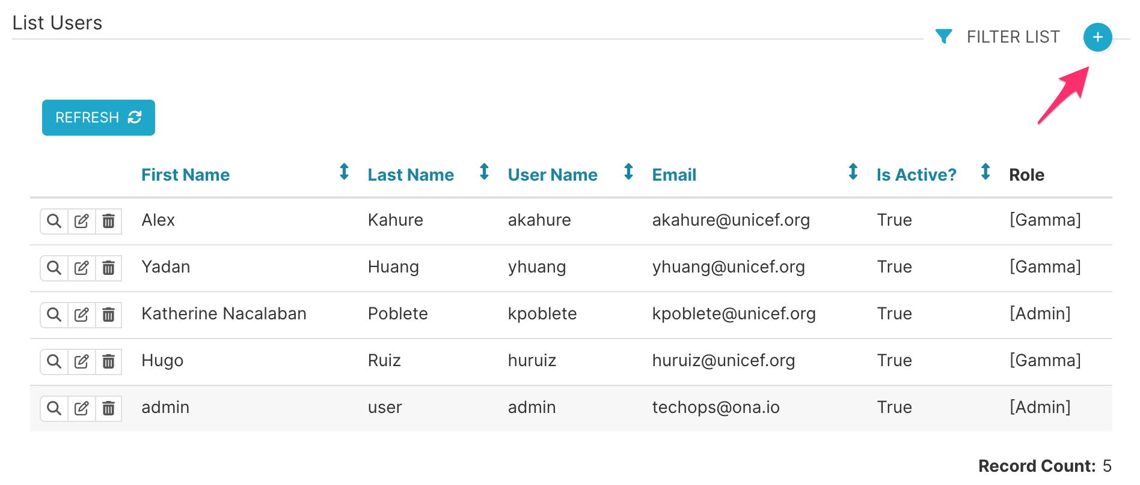

1. Fill out the required fields in the **Add New User**.

**NOTE:** You can only create one user per email address.

* 1. Add the first and last name of the user.
  2. Add the username for the user. We recommend using something the user will remember, such as the text before the at (@) in the email associated with this account. For example, for [mschroeder@ona.io](mailto:mschroeder@ona.io), I would use mschroeder.
  3. Check the Active checkbox.
  4. Enter their organizational or personal email.
  5. Add their appropriate role.
  6. Enter a password the user will easily remember.
  7. Enter the password again.

**NOTE:** Once you create a user, only that user can edit their password. Administrators cannot reset passwords in Canopy Discover’s UI. Administrators can only do it using a command line. Please guide non-Ona users to change the password to something they will easily remember and alert them it cannot be easily changed.

* 1. Then, click **Save**.

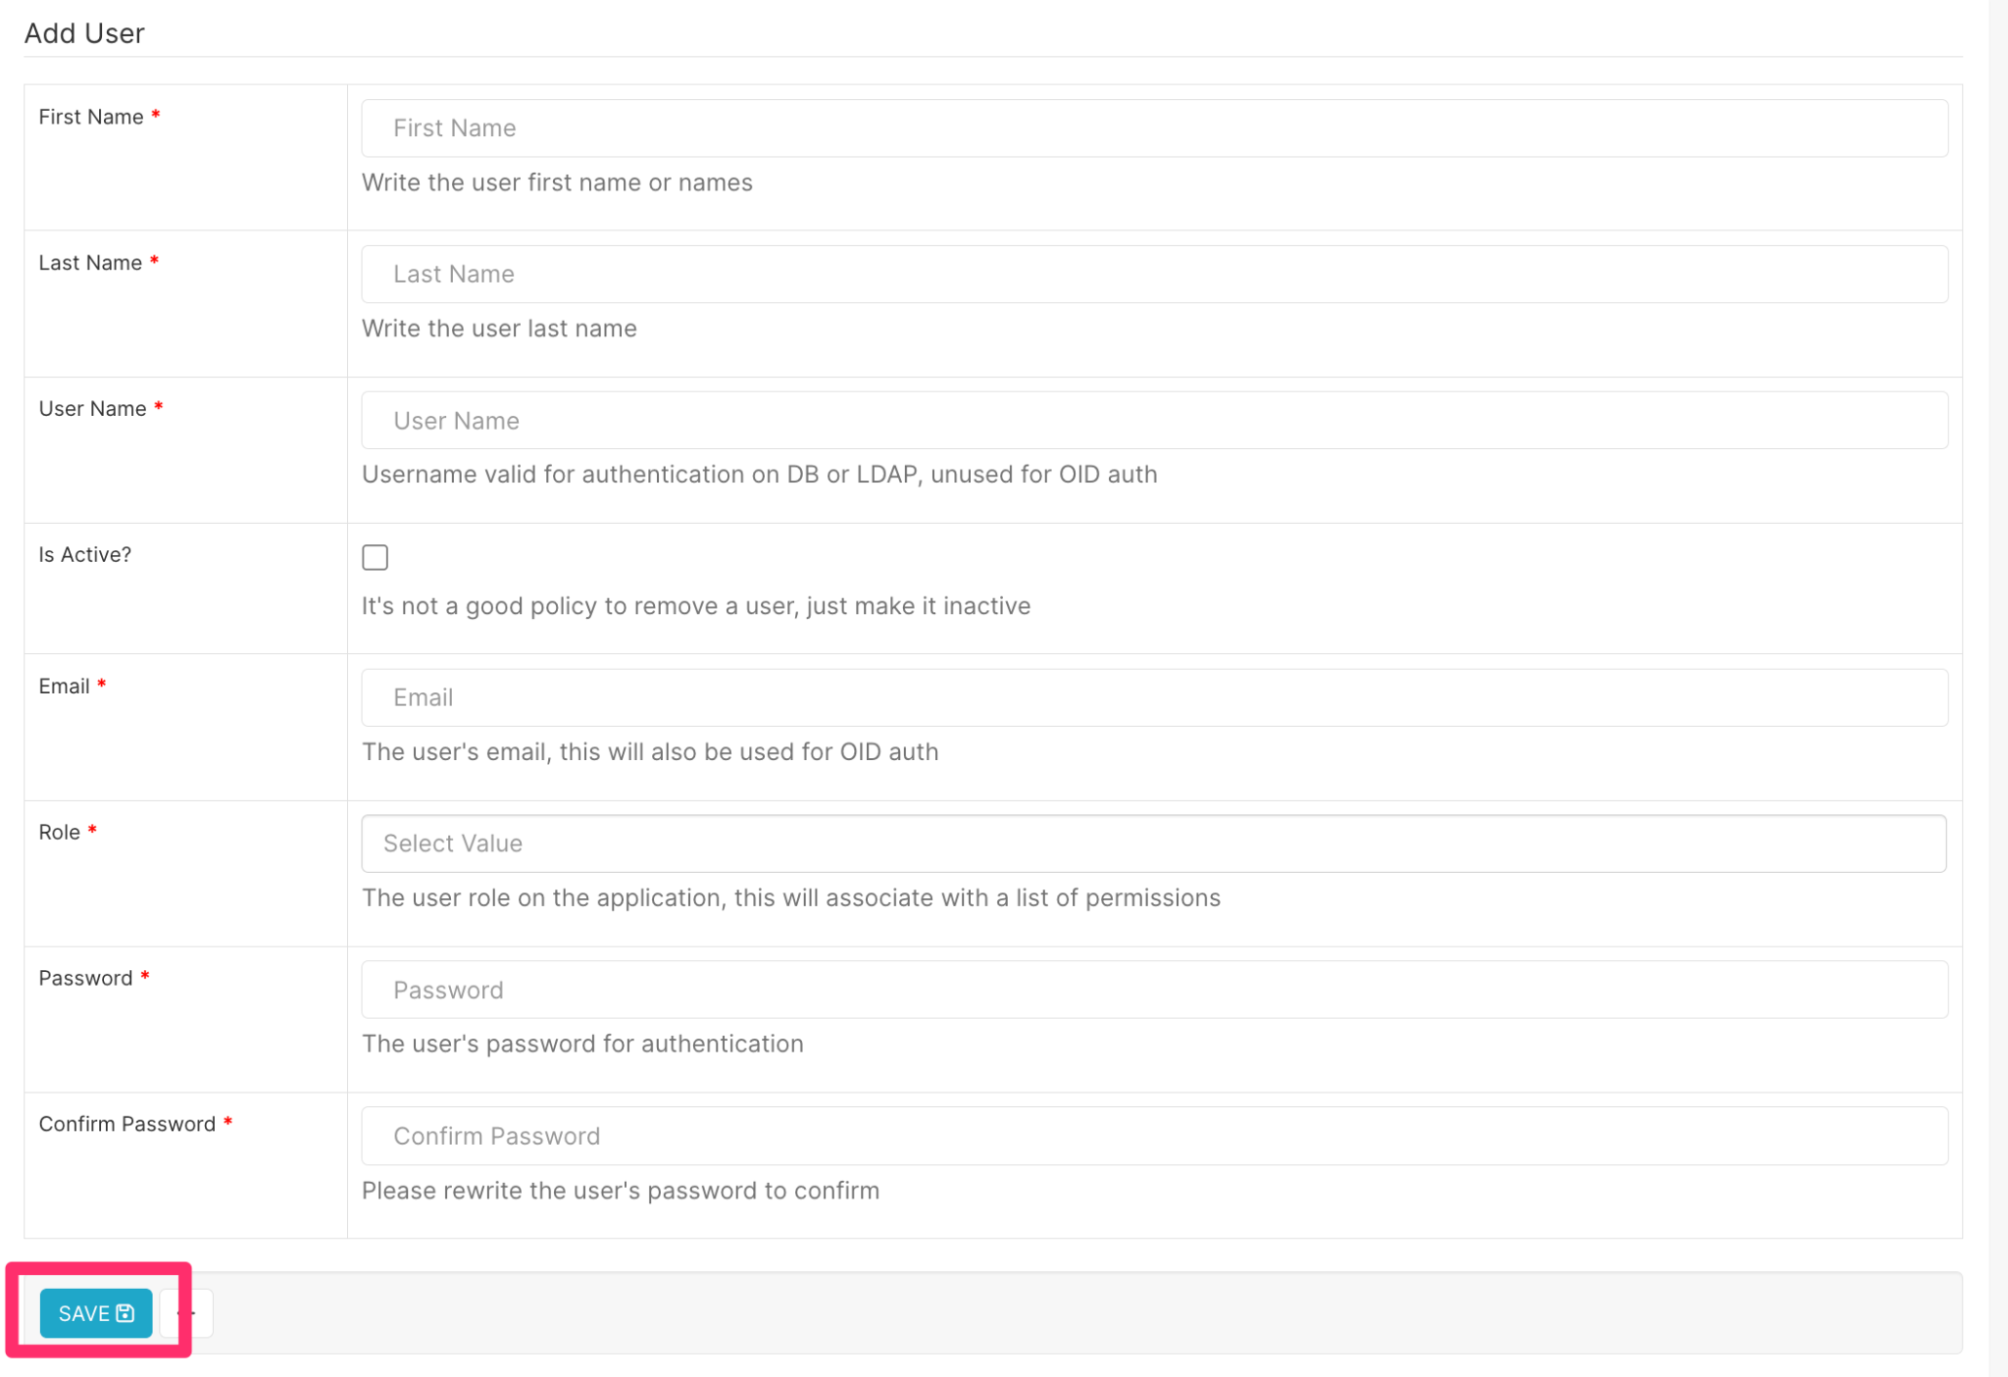

## Granting Access to a Datasource

To view your data source and begin creating visualizations and dashboards, you need to make sure you have access using the following steps:

## 

### Adding a Datasource to a Role

1. Hover over **Settings** and click on **List Roles.**

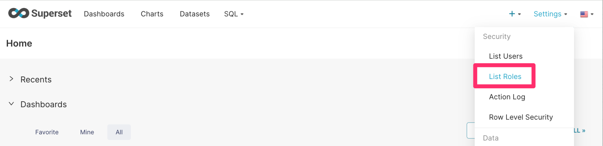

1. The various roles will be displayed, as shown below.

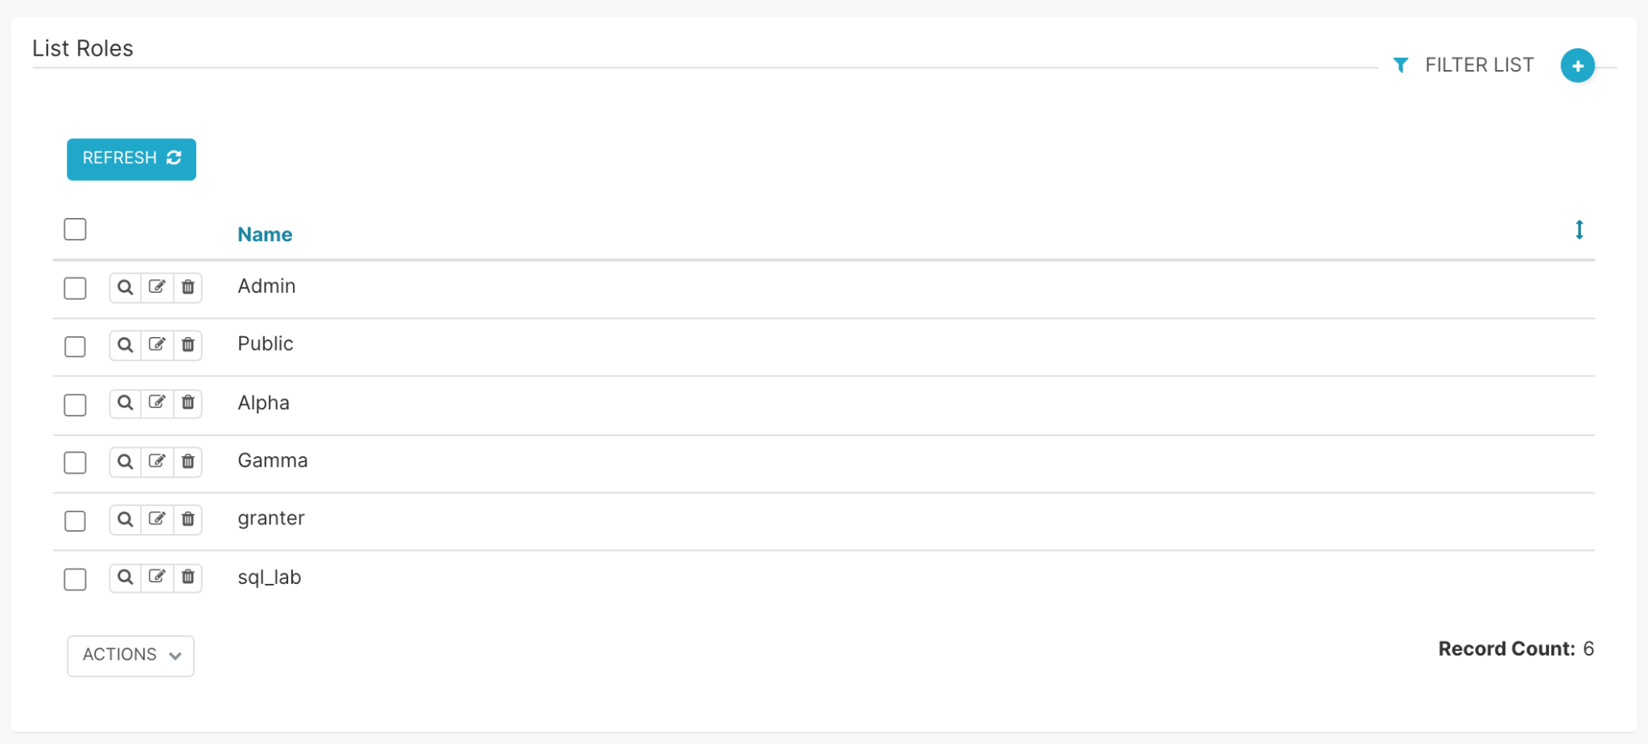

1. From the **List Roles** page, click on **Show Record.**

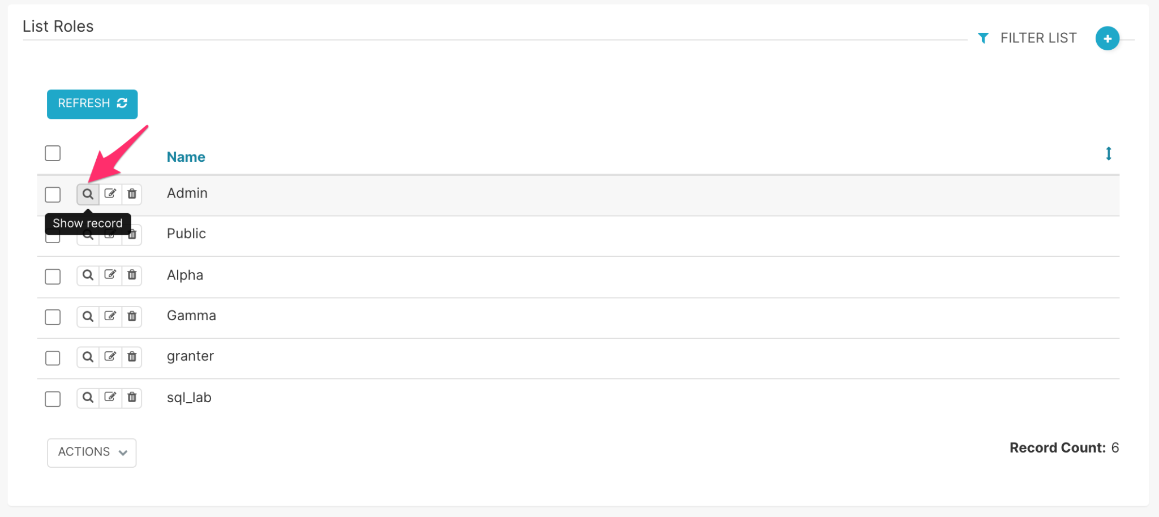

1. Upon clicking **Show Record,** You will be able to view the permissions for the role selected. You can also view the list of users who have been assigned the role under the **List Users** tab.

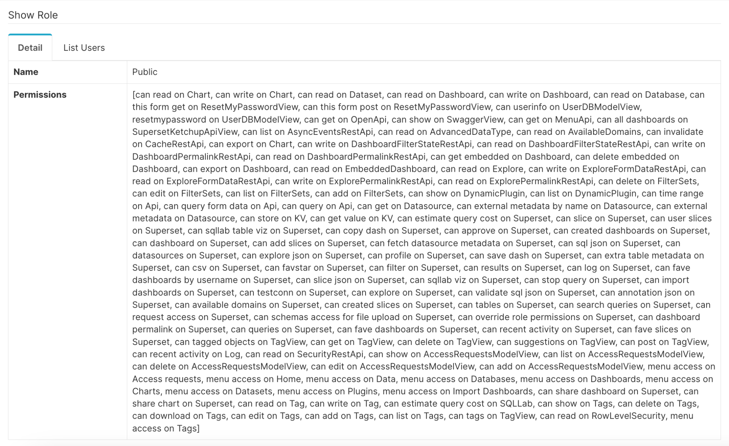

1. To grant access to a data source from the **List Roles** page, select **Edit Record.**

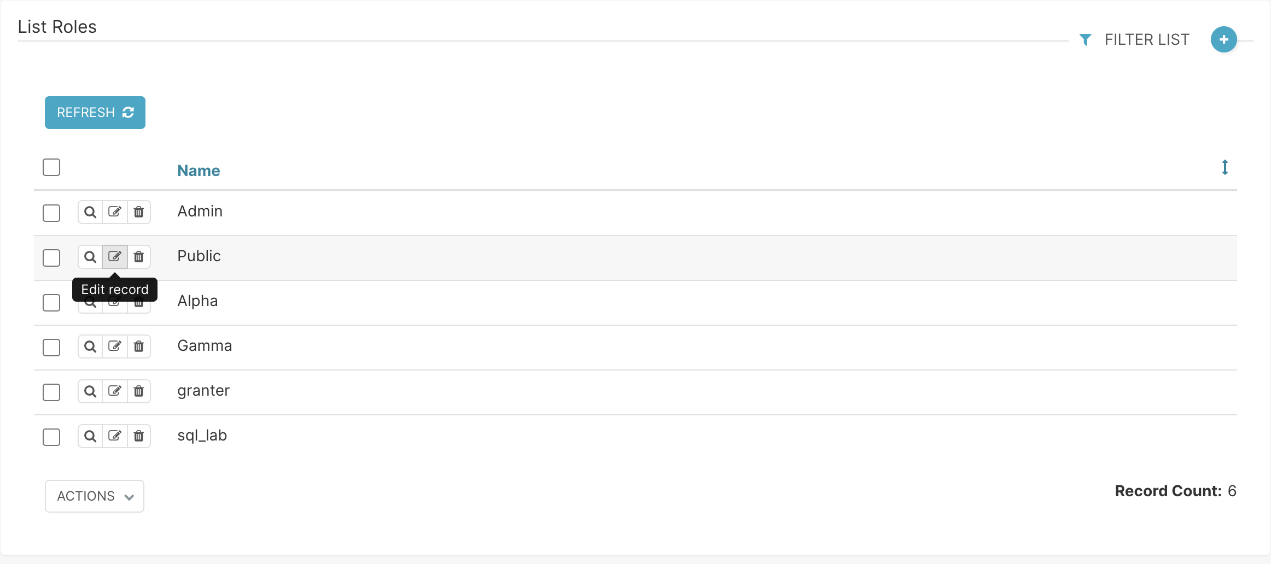

1. In the **Permissions**, click inside the text window, then type the name of the data source you need access to. It should pull up data sources and permissions with similar names. Once you find your data source, please add it and click **Save**.

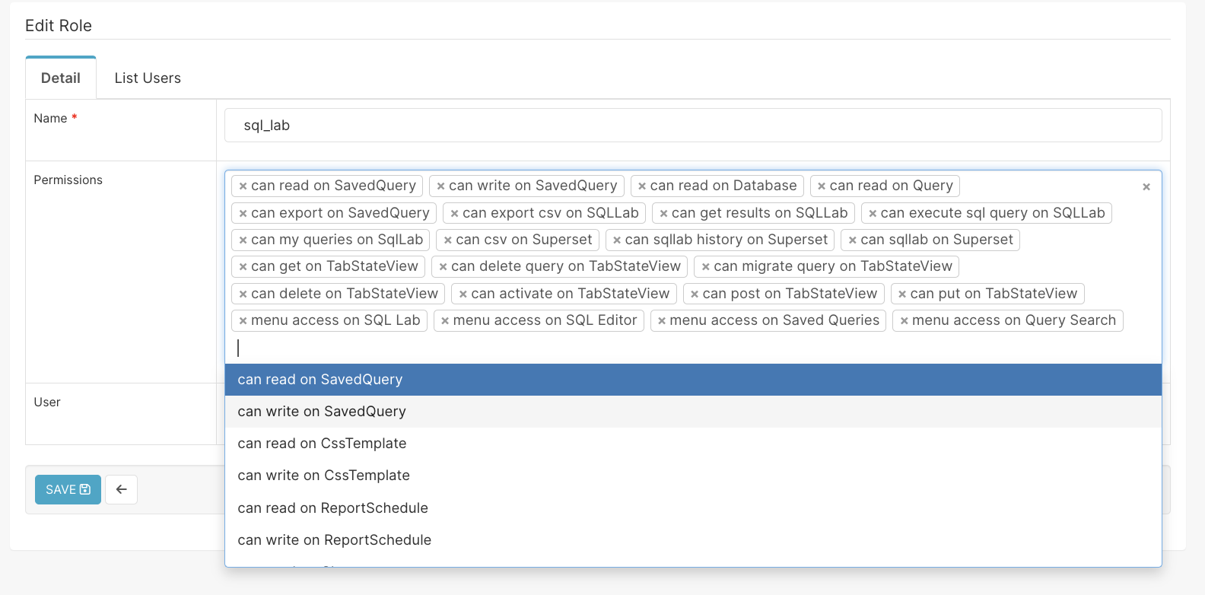

**NOTE:** You only need to do this for every new data source and any dashboard-specific user roles.

### Add a Role to a User

1. Hover over **Settings**, and click **List Users.**



1. Under the **List Users** page, find a user you would like to add a role to. Then, click **Edit Record.**

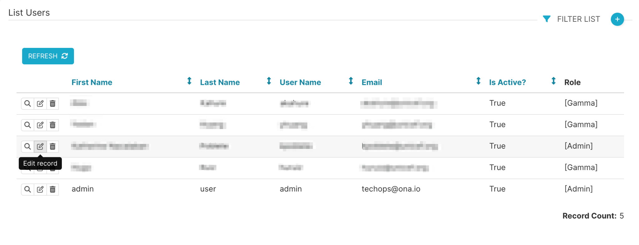

1. Click on the textbox next to **Role.** A drop-down with all the possible roles is available. Select the permission you would like to add to the user, and then, click **Save.** For more information on the different permissions, kindly see this [help documentation](https://superset.apache.org/docs/security#roles).

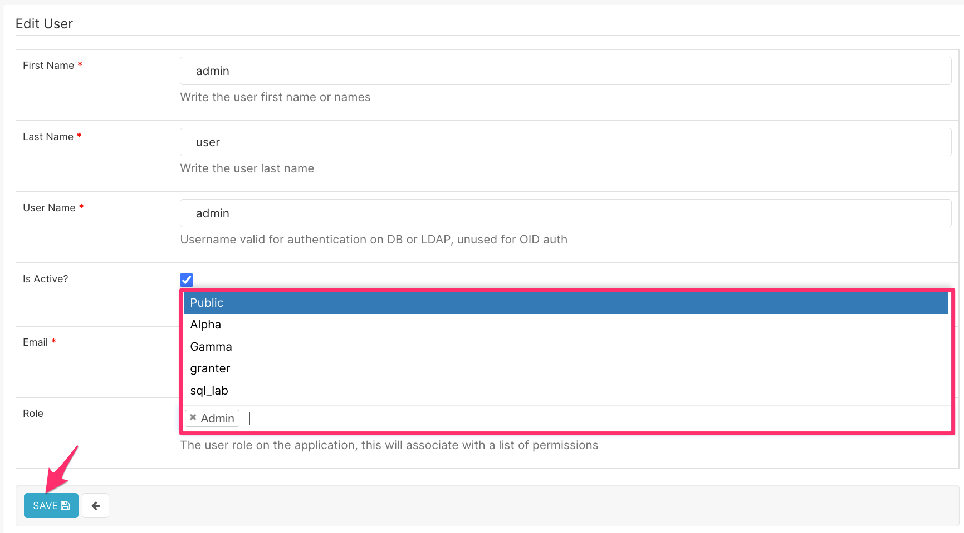

## Accessing a Datasource

To view your data source and begin creating visualizations and dashboards, you can access it using the following steps:

1. Click **Dataset.**



1. The **Datasets** page will show you all the tables you have access to.

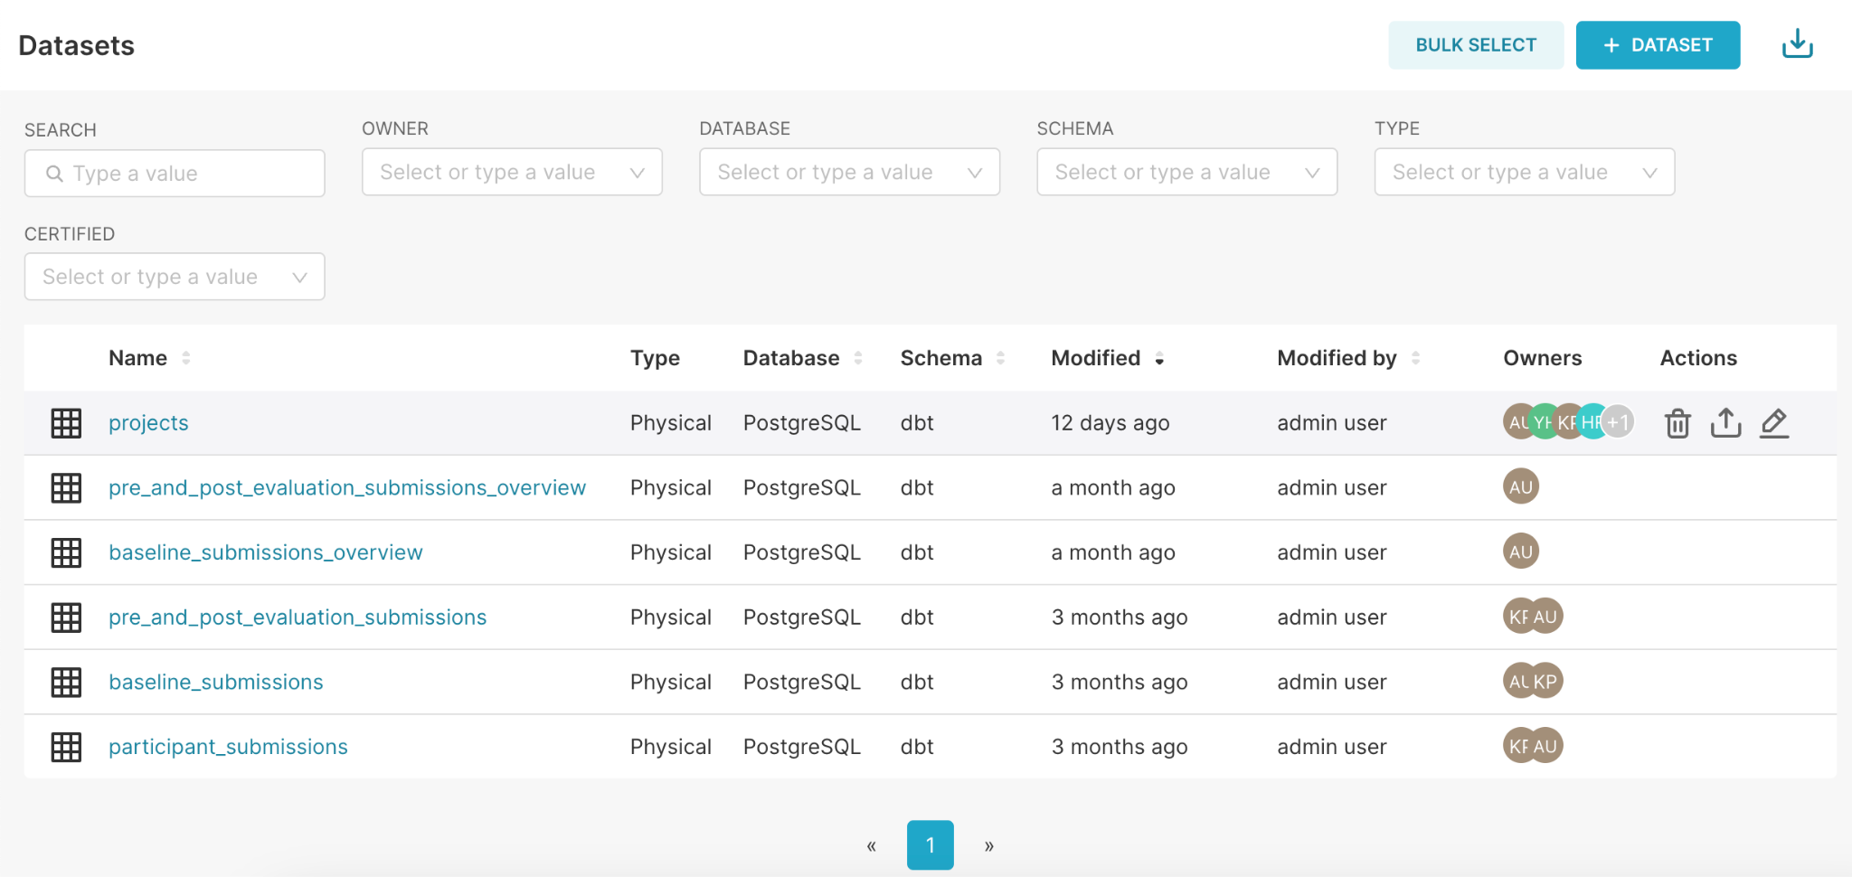

1. You can also filter by various criteria: Owner, Database, Schema, or Type.
   1. **Owner** allows you to search based on the owner of the database.
   2. **Database** allows you to search by the database the table is associated with.
   3. **Schema** allows you to search for tables based on the schema they are associated with.
   4. **Type** allows you to search based on the type of database (physical or virtual).
      1. **Physical Database:** A database associated with tables and customized data views.
      2. **Virtual Database**: A database that consists of SQL queries that aggregate values from multiple columns. When specifying SQL, the data source acts as a view. Canopy will use this statement as a subquery while grouping and filtering the generated parent queries.

## Uploading a CSV

Data can be uploaded as a CSV file to the database, but the ‘Allow file uploads to database’ must be enabled on the database’s settings. To upload a CSV file, you will need to:

1. Hover over the **plus sign (+)**, hover over **Data**, and select **Upload CSV to database**.

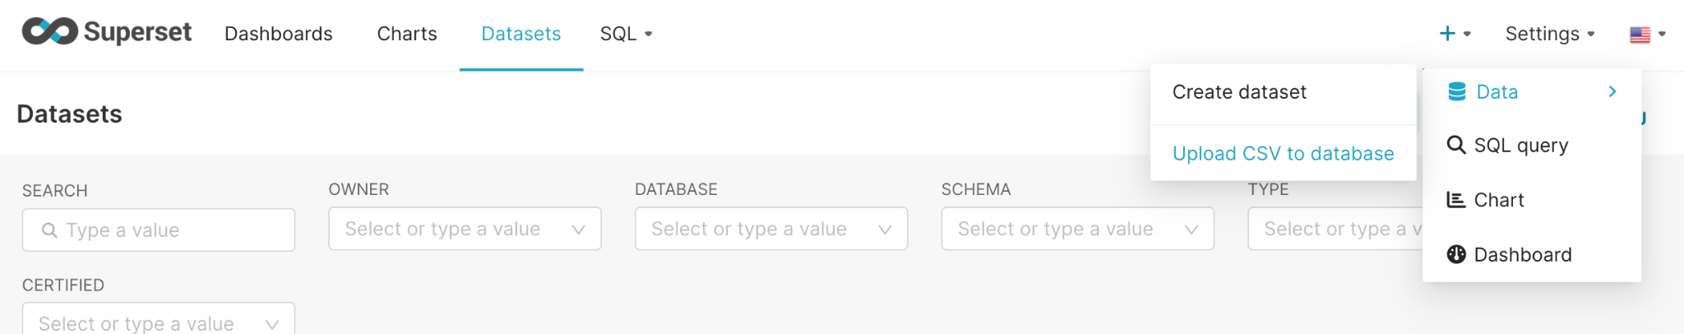

1. On the **CSV to Database configuration** window:
   1. Enter the desired **Table Name**
   2. Upload the **CSV File** from your local machine
   3. Select the desired database where you would like this table to be saved
   4. Select what action should be performed, if the table exists:
      1. **Fail:** Do nothing to the table.
      2. **Replace:** Drop and recreate the table.
      3. **Append:** Insert data into the existing table. This action will add data to the existing data in the table.
   5. You can leave the rest of the fields as they are.
2. Click **Save.** You will be redirected to the **Datasets** page, the created table’s location.

## Review and Edit a Table

Once you have access to a table, you may want to review the table contents:

1. From the home page, hover your cursor over **Datasets.**
2. Once you have found the table, hover your cursor on the table you would like to review or edit. You will see 3 icons to the right, under the **Actions** column, that you can click on, as shown below.

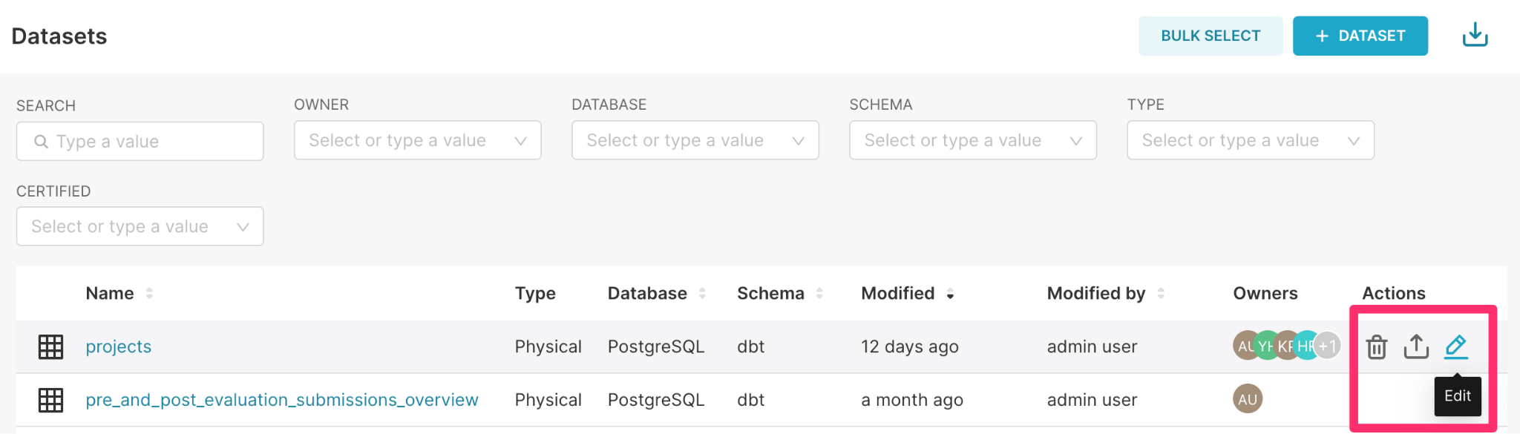

### Table actions

Three actions can be performed on a table:

1. **Delete:** The first icon allows you to delete the table. Some tables may be linked to other charts and dashboards. You will not be able to delete them until they are unlinked to charts and dashboards. Deleting tables linked to other datasets may result in the loss of data and dashboards already created with this data. Once you select the deletion icon, you will be asked to type the name of the dataset to confirm the deletion.
2. **Export:** The second icon allows you to export the table in .yaml format. YAML format is commonly used for configuration files and in applications where data is being stored or transmitted. You may want to export your table if you would like to edit your dataset in a text editor and for portability across different programming languages and platforms.
3. **Edit:** The third icon is the edit icon. It allows you to edit the contents of the table.

### Edit a table

If you select the edit icon, it will display information about the table:

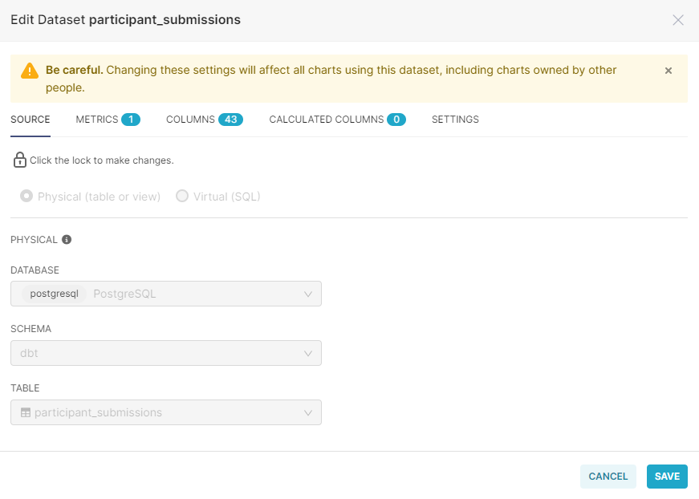

From the Edit Dataset, several tabs allow you to edit table components.

1. **Source:** You can make changes to the source section after clicking on the lock icon to break the lock.

**Note**: Changing the dataset configuration affects all the charts using this dataset. Changing settings may affect other charts in undesirable ways. If you select physical, you will be required to select a schema. However, if you select virtual, you will be required to enter SQL queries



1. **Metrics:** Allows you to add metrics using SQL expressions. In this tab, you can write SQL queries aggregating values from multiple columns (e.g. SUM(total_participants) / SUM(total_target)) and make these metrics available as columns.

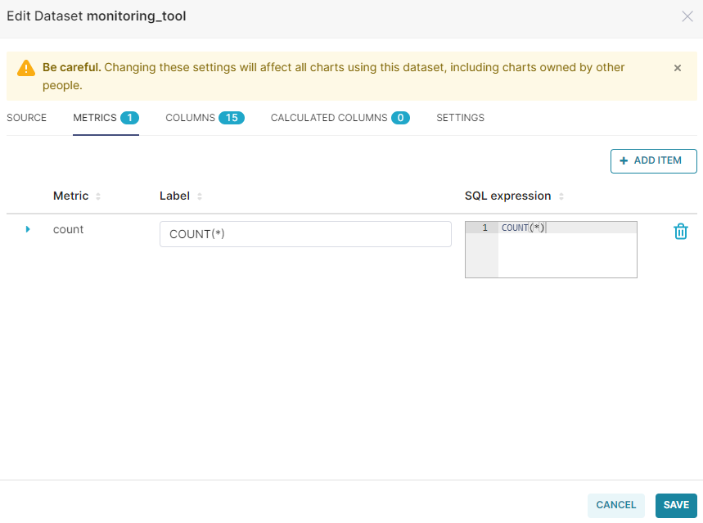

1. **Columns:** Allows you to configure column properties for how a data field can be used when creating charts and graphs. Below are the column properties available:
2. **Is temporal:** The data field has a time component. When checked, the data field can be used as a date/time field in charts and graphs [Time Granularity].
3. **Is filterable:** The data field can be used to filter charts and graphs.
4. **Is dimension:** The data field is groupable and can be used in **Group By** or any aggregations in the visualization.

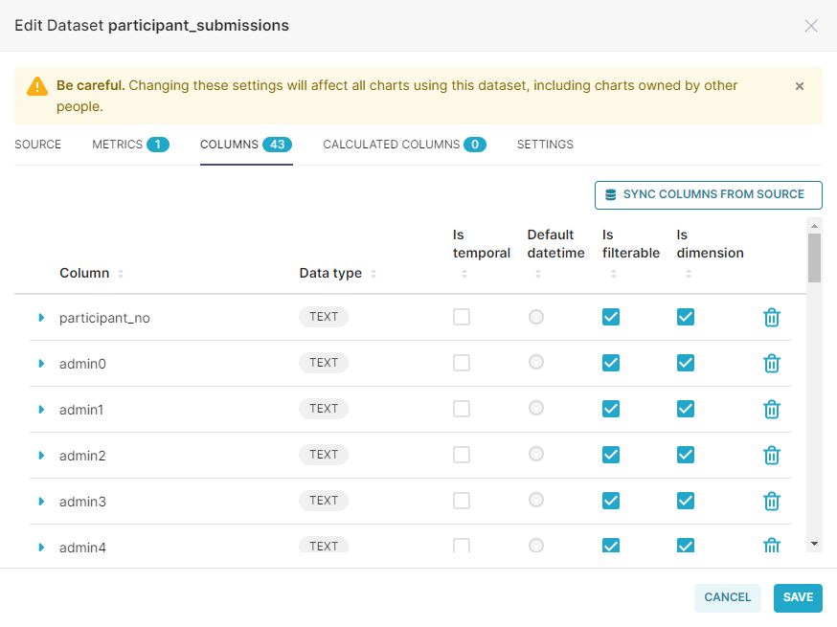

4. **Calculated Columns:** Allows you to write SQL queries customizing the appearance and behavior of a specific column (e.g. CAST(recovery_rate) as float). Aggregate functions aren't allowed in calculated columns.

## Charts

To create/update charts and visualizations, you can follow this step-by-step guide below::

1. Click **Charts**.

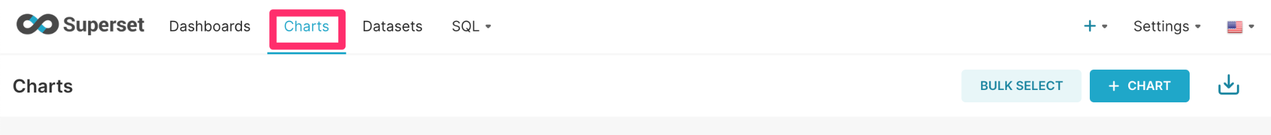

1. Add a new chart by clicking **+ Chart**, in the top right corner of the **Charts** page.

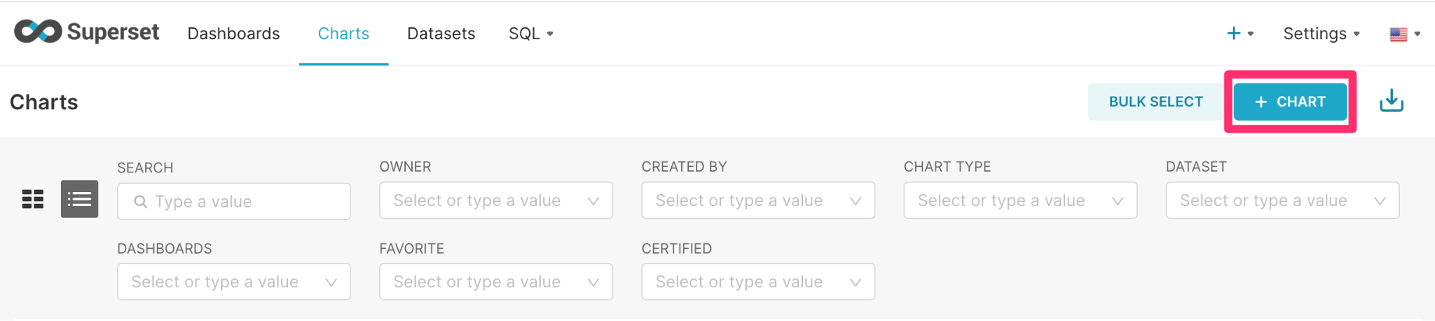

Alternatively, you can add a new chart by hovering over the **plus sign (+)** and clicking **Charts**.

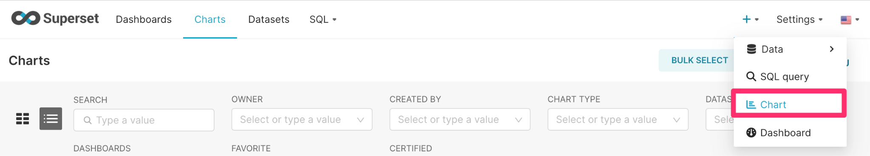

1. Set up your chart by:
   1. Selecting the dataset you would like to use to create your chart for the **Choose a Dataset** field
   2. Select the chart type from the **Choose chart type** section.
   3. Select **CREATE NEW CHART.** You will be directed to the **Chart UI.**

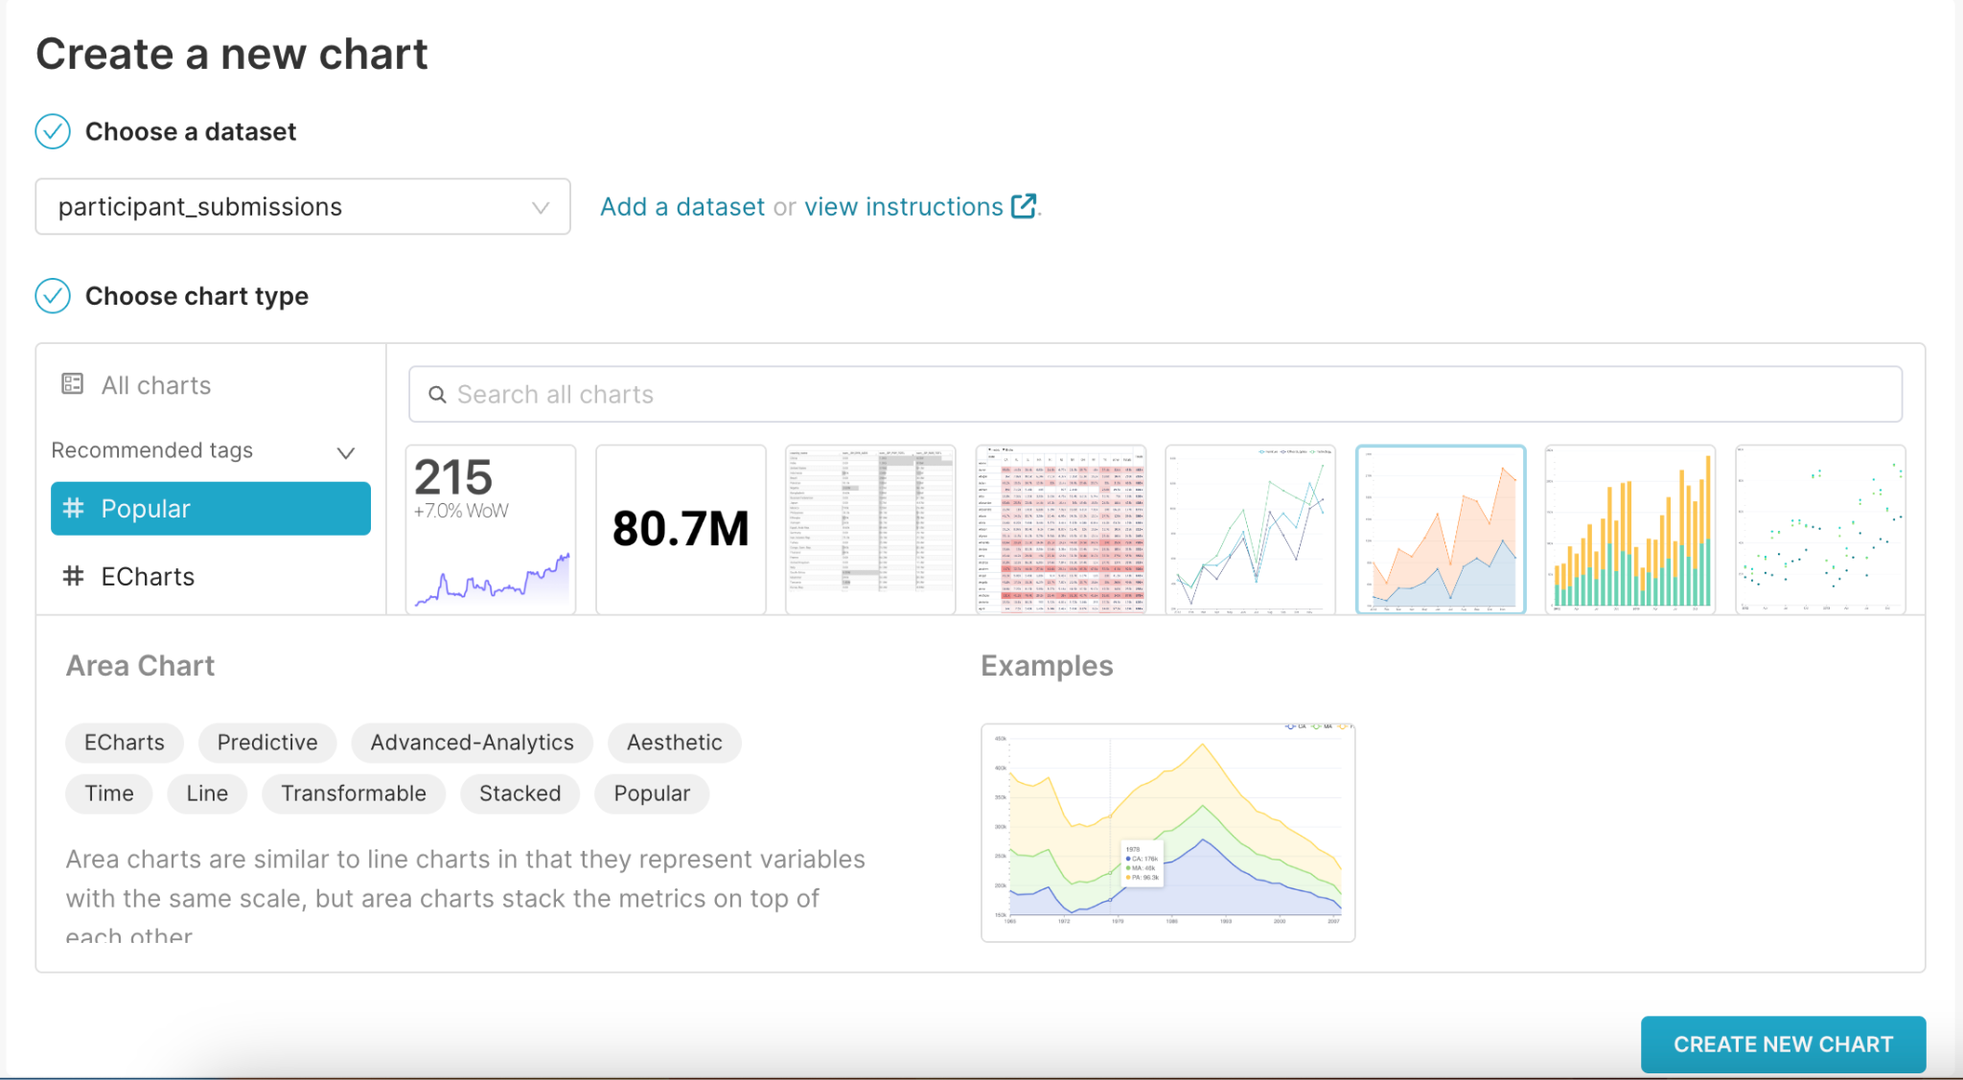

### The chart UI

The Chart UI is used to define specific parameters for your chart and apply various styling options based on your visualization type.

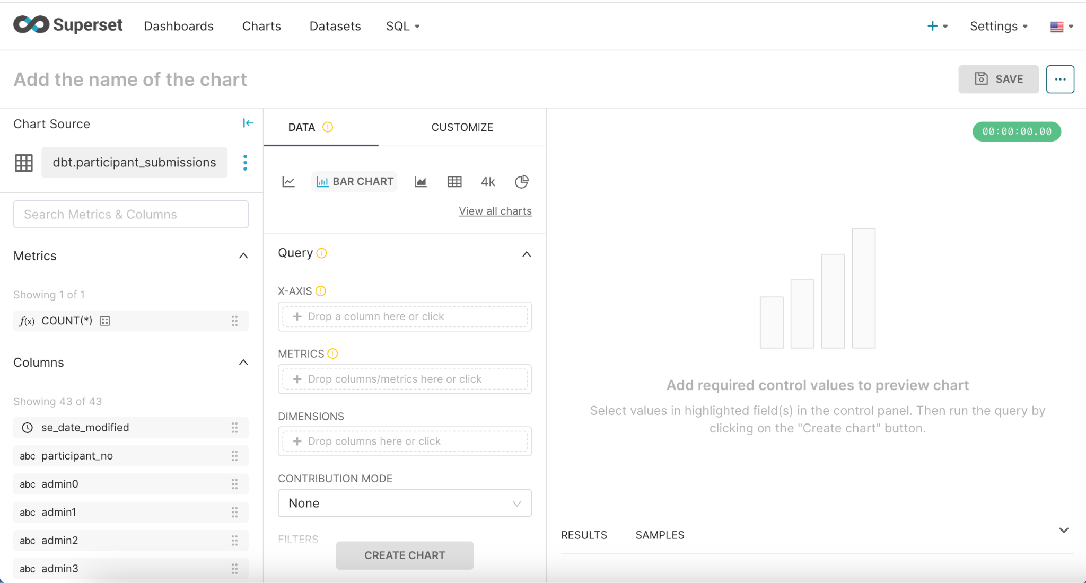

1. **Add the name of the chart** allows you to specify the name of the chart.
2. **Chart Source** defines the data source/ table used to create the chart.
3. **Metrics display** all your saved metrics for the data source.
4. **Columns** list all the columns available within your data source.
5. **Data** and **Customize** tabs help you create the look and feel of the visualization you would like.

If you are working with a large dataset, the **Search Metrics & Columns** field enables you to quickly find the data you need. Each data type includes a small icon conveying its type:

● **ƒ**: Function used for metrics

● **Clock:** The data source’s time column

● **ABC:** Text data

● **#:** Numeric value data

You can edit a data source/table by clicking on the ellipsis on the right side of the name of the dataset and clicking **Edit dataset**. You can select a different data source by clicking the **Swap dataset** option from the same menu. This will result in a popup screen with other data sources that you can select to create charts with.

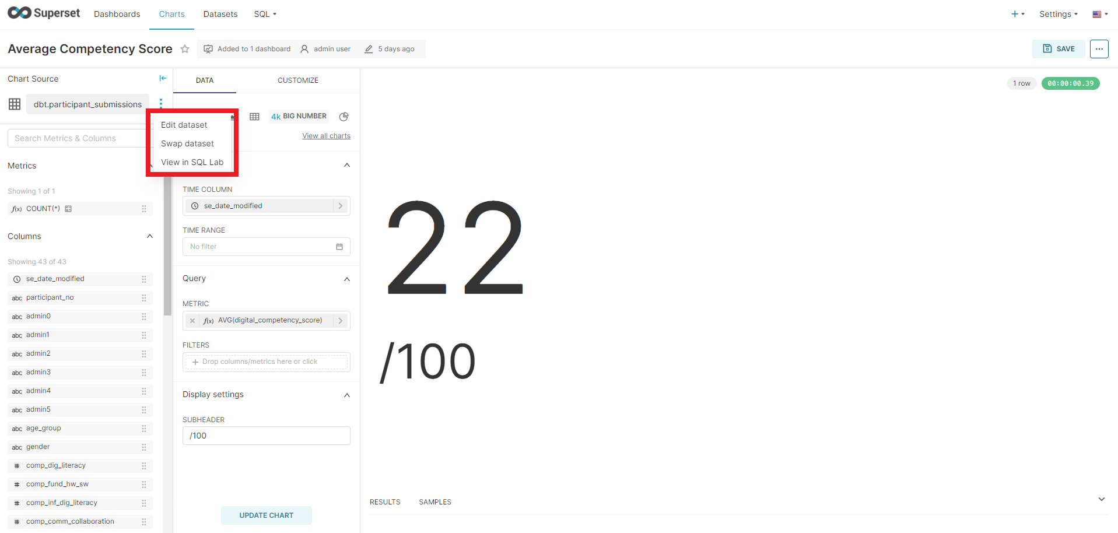

**NOTE**: It is important to be very careful when changing the dataset. There is a possibility you may break the chart if the chart relies on columns or metadata that do not exist in the newly selected dataset.

#### Visualization type

You can select the type of chart that would create the best visualization for your data from the charts page. There are different types of visualizations on Superset, such as bar charts, line charts, big numbers, pie charts, and treemaps. The type of visualization you choose depends on the story you want to tell with your dashboard. We will focus on bar charts, time series, pie charts, line charts, big numbers, the table view, a pivot table, a country map, and a Deck.gl scatter plot.

##### Bar chart

For the bar chart, you may want to visualize data with several x-axis options and a count or numeric value on the y-axis. To create a bar chart, you will need:

* **Metric:** These can be previously created values in your table. You can also create a simple metric on the simple tab, or you can create the metric in Custom SQL. When you are creating a simple metric, you can select the column/field name you want to use, and the aggregate value (COUNT, COUNT DISTINCT, AVERAGE, SUM, MAXIMUM, or MINIMUM). You can also give the metric a unique name by clicking the pencil (edit) icon next to “My Metric”. When you are done with the metric, click save to save changes or close to discard any changes you made.
* **Filters:** Add the specific data field to add desired filters for the chart.
* **Dimensions:** Add the specific data fields to visualize on the x-axis of the chart.
* **Breakdown:** You can break down the chart by any of the data fields in the query or table used to create the chart.
* **Row limit:** You can change the number of data values that can be visualized in a chart.

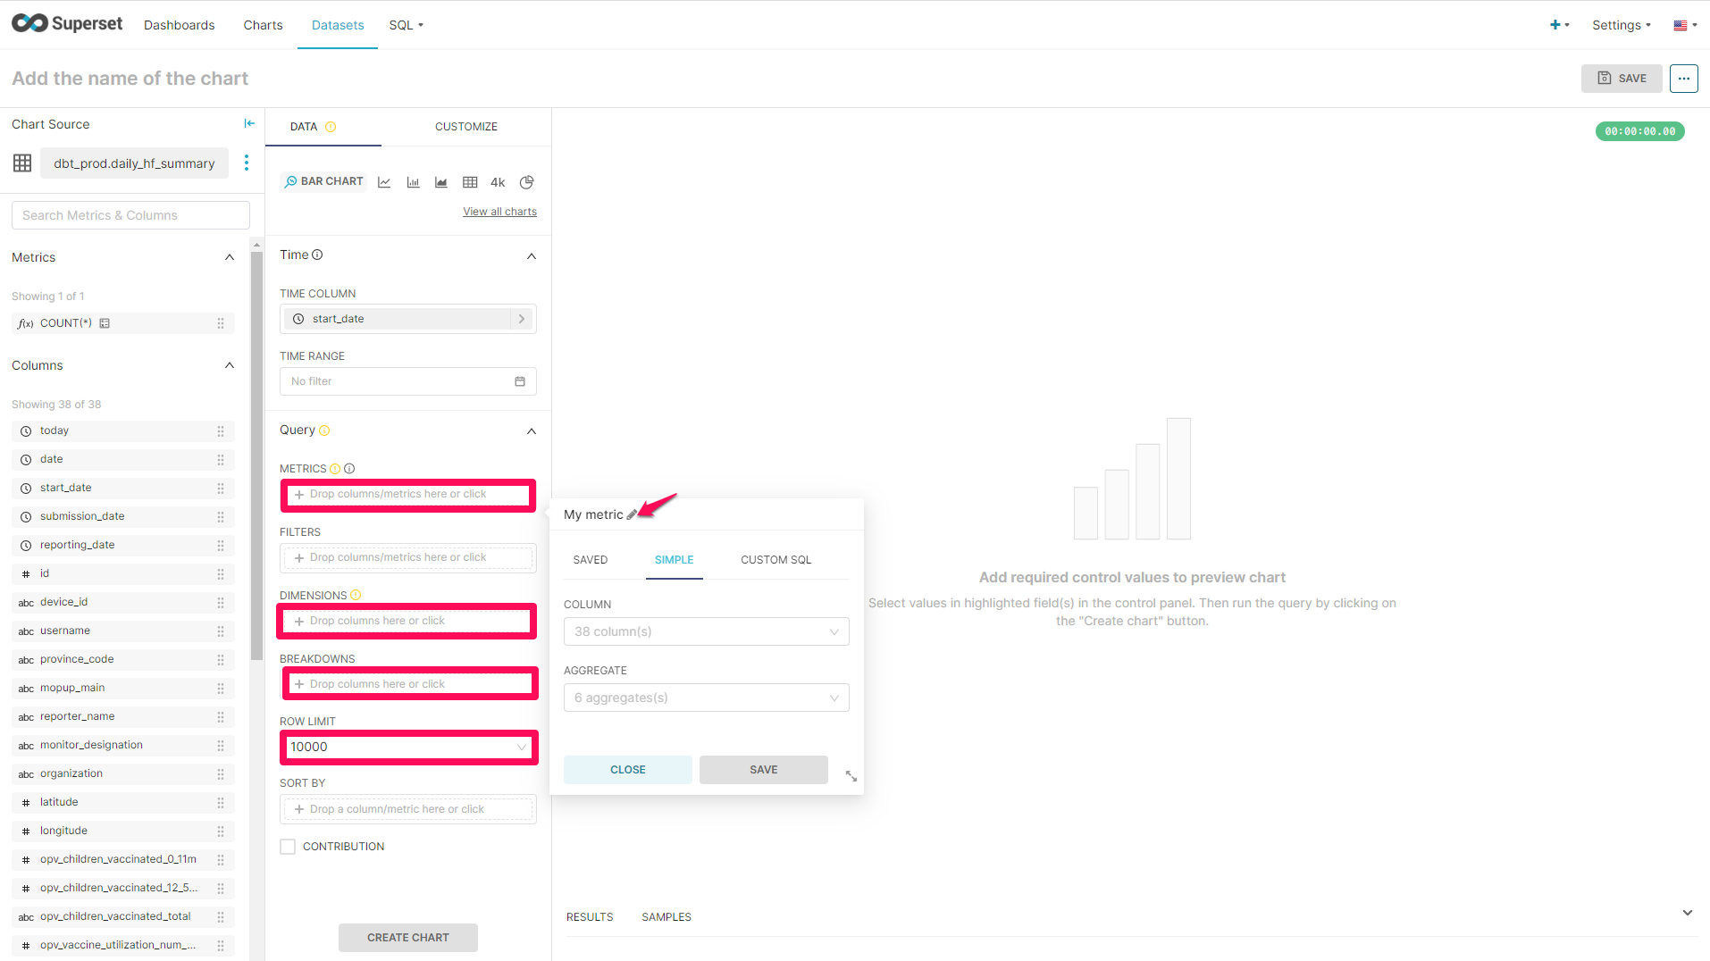

###### Styling

You can update the styling for the chart by clicking on **Customize.**

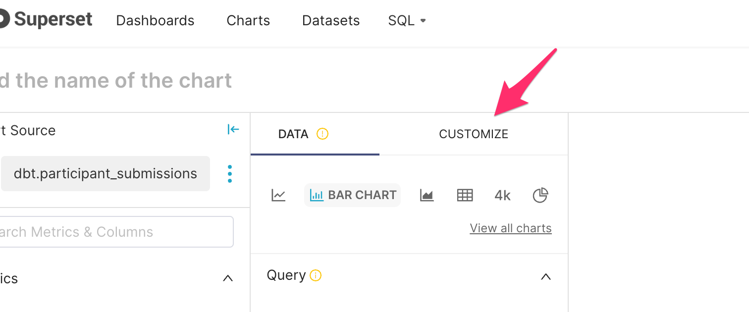

The different styling options will depend on the type of chart being created. You can choose the following stylings:

* **Color Scheme:** A drop-down with different color schemes.
* **Legend:** If you select this option, the metric name will appear on the graph. We recommend only including this when you are visualizing more than one option, otherwise, this information can be provided in the title.
* **Bar Values:** This option will display the count or number at the top of the bar in a bar graph. This is an option for bar charts only.
* **Stacked Bars:** This option should only be used when you are visualizing data with multiple options for x-axis values with their respective breakdowns, such as the number of households with and without improved latrines by district. This is an option for bar charts only.
* **Sort Bars:** This option will sort bars by the x-axis values (i.e. alphabetically for text and chronologically for numeric values). This is an option for bar charts only.
* **Y-AxisFormat:** This option allows you to determine how the numeric/count should be visualized. For example, *.1s* means that only whole numbers will be visualized.
* **Y-Axis Label:** You can add a label for the Y-Axis. Sometimes this is not necessary as it is clear from the title.
* **X-Axis Label:** You can add a label for the X-Axis. Sometimes this is not necessary as it is clear from the title.
* **Bottom Margin:** This option determines how much space is on the bottom of the chart. Too high a value, you can have a lot of white space on the bottom. Too low a value, you can have some axis labels cut off. You can also select auto (default) to assist you in choosing the best.
* **X Tick Layout:** This option allows you to decide how the labels on the x-axis will be displayed. Auto is the default option.
* **Reduce X Ticks:** This option allows you to reduce the number of x-axis labels.

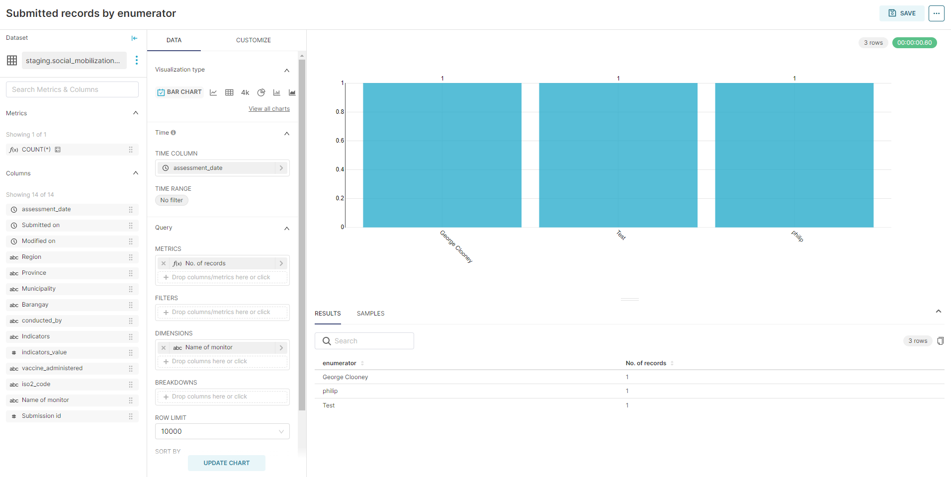

*Fig. Sample bar chart*

##### Time series - bar chart

This chart is the same as the Bar Chart, except you include time. This chart type is ideal if you are collecting a data value over larger time intervals, such as quarterly reporting of the number of beneficiaries for a specific program. If you use this chart type, you will need a temporal data field/column (date/datetime field).

###### Define a temporal data field/column

Select the value you want to use to define the time along the x-axis as the time column field. Only columns that have a date or time component and are defined as temporal will be visible here.

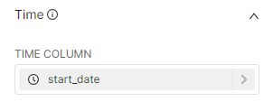

You can also select the time range for the chart. To change the time range, select the current time range button (“Last week” in the graphic below).

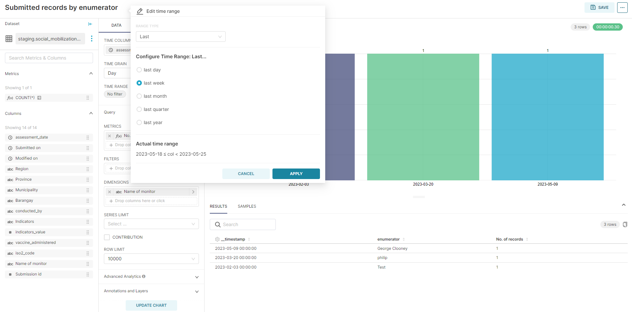

The Edit time range panel appears. There are several different range types offered:

1. **Last:** When selecting **Last** in the Range Type field, Superset will display a date range that starts at the beginning of the selected option and ends at 23:59:59 yesterday. It does not include data from today, to avoid providing partial data entry.
2. **Previous:** When selecting **Previous** in the Range Type field, Superset will display a date range that is based on the previous calendar section - options include the previous calendar week, calendar month, or calendar year.
3. **Custom:** When selecting **Custom** in the Range Type field, Superset will display a date range based on your defined start and end date. Options include:

* **Start (Inclusive: Includes the specified starting date) & End (Exclusive: Excludes the specified ending date)**
  + **Specific Date/Time:** Enter date & Time in yyyy-mm-dd hh:mm:ss format.
  + **Relative Date/Time:**
    - **Value:** Enter a number
    - **x Before:** x is the Seconds | Minutes | Hours | Days | Weeks | Months | Quarters | Years
  + **Now:** Selects the current date & time.
  + **Midnight:** Selects today at 00:00:00.

1. **Advanced:** When selecting **Advanced** in the Range Type field, Superset uses its AI logic capabilities to determine a specific date based on your input. Examples of Starting or Ending text include: 3 weeks ago, today now, next 2 weeks, next year, yesterday, last Monday.

**NOTE**: If no start or end date is specified, Superset will enter **No filter**, which means that all data is included up to and including the current date & time.

Once you have defined your time range filter, select **OK**.

###### Styling

Additional styling options (under the Customize tab) available with the Time Series - Bar Chart include:

* **Show Range Filter:** Allows you to determine whether to display the interactive time range selector.
* **Rich Tooltip:** This will show a list of all the series for that time point selected, if the option is selected.
* **Extra Controls:** If this option is selected, it will show additional options like making multibar charts either stacked or side-by-side.
* **Line style:** This option allows you to select how the linear interpolation is defined according to the d3.js.
* Other options are related to the X and Y axes:
  + **X Tick Layout:** This option defines the way the X-axis ticks are laid out on the X-axis
  + **X-Axis Format:** This option defines how the x-axis date format label is displayed.
  + **X bounds:** When this option is selected, the min and max values of the x-axis are displayed.
  + **Reduce X ticks:** This option allows you to reduce the number of x-axis labels.
  + **Y bounds:** When this option is selected, the min and max values of the y-axis are displayed.
  + **Y Log scale:** When this option is selected, the y-axis will be displayed using a log scale.
  + **Y-Axis Format:** This option defines how the y-axis date format label is displayed.
  + **Y-Axis Limits:** This defines the bounds of the Y-axis. If the bounds are left empty, the bounds are dynamically created based on the min/max values of the data.

##### Pie chart

The pie chart is best when you do not have many options, ideally 5 or less options. For this chart, you do not need to define the time as there is no dependence on time. The chart below shows an example of a pie chart with total records by daily summary category:

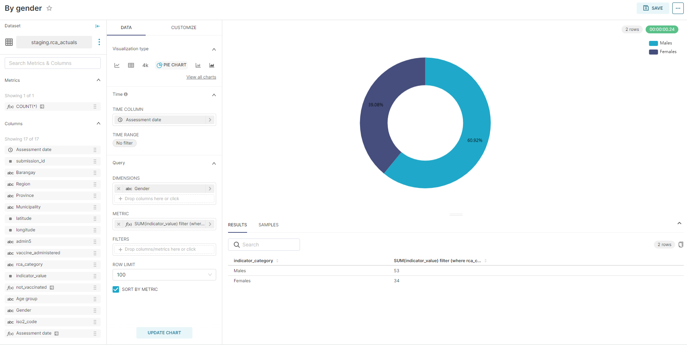

*Fig. Sample pie chart*

In the **Data** section, you can define the following:

* **Dimensions:** The categorical field is added to this section.
* **Metric:** These can be previously created values in your table. You can also create a simple metric on the simple tab, or you can create the metric in Custom SQL. When you are creating a simple metric, you can select the column/field name you want to use, and the aggregate value (COUNT, COUNT DISTINCT, AVERAGE, SUM, MAXIMUM, or MINIMUM). You can also give the metric a unique name by clicking the pencil (edit) icon next to “My Metric”. When you are done with the metric, click save to save changes or close to discard any changes you made.
* **Filters:** Add the specific data field to add a filter.
* **Row limit:** You can change the number of data values that can be visualized in a chart.

###### Styling

Additional styling options available with the pie chart include:

* **Label Type:** This allows you to determine how the label will be viewed in the pie chart. You can view as the category name, value, percentage, category name, and value or category name and percentage
* **Donut:** The pie chart will be viewed as a donut.
* **Show label:** If the option is selected, the pie portions labels will be shown. Otherwise, they will not be viewed.
* **Put labels outside:** If this option is selected along with **Show label**, the labels will be outside the pie portions. If just the **Show label** is selected, the labels will be on the inside of the pie portions.

##### Line chart

A line chart is a great chart to visualize continuous data over time for one indicator. A good example of this chart is Records submitted over time by age categories. This can be dependent on time, but you will need a temporal data field/column.

###### 

*Fig. Sample line chart*

In the **Data** section, you can define the following:

* **Metric:** These can be previously created values in your table. You can create a simple metric on the simple tab, or you can create the metric in Custom SQL. When you are creating a simple metric, you can select the column/field name you want to use, and the aggregate value (COUNT, COUNT DISTINCT, AVERAGE, SUM, MAXIMUM, or MINIMUM). You can also give the metric a unique name by clicking the pencil (edit) icon next to “My Metric”. When you are done with the metric, click save to save changes or close to discard any changes you made.
* **Filters:** Add the specific data field to add a filter.
* **Grouped by:** Add the specific data field to group the chart data
* **Series limit:** This option allows you to limit the number of time series that will be displayed on the x-axis of the chart.
* **Sort by:** This option defines the metric that will be used to determine which value is the top series.
* **Sort descending:** If this option is selected, the data will be sorted descending. Otherwise, it will be sorted ascending.
* **Contribution:** This calculates the metric’s contribution to the total.
* **Row limit:** You can change the number of data values that can be visualized in a chart.
* There are also additional advanced analytic functions, annotation layers, and predictive analytics.

###### Styling

Additional styling options available with the line chart include:

* **Marker:** If this option is selected, data points will be visualized as circles on the data line. Otherwise, all the points will be connected to create one line.
* **Line style:** This option allows you to select how the linear interpolation is defined according to the d3.js.
* Other options are related to the X and Y axes:
  + **X Tick Layout:** This option defines the way the X-axis ticks are laid out on the X-axis
  + **X-AxisFormat:** This option defines how the x-axis date format label is displayed.
  + **X bounds:** When this option is selected, the min and max values of the x-axis are displayed.
  + **Y bounds:**  When this option is selected, the min and max values of the y-axis are displayed.
  + **Y Log scale:** When this option is selected, the y-axis will be displayed using a log scale.
  + **Y-Axis Format:** This option defines how the y-axis date format label is displayed.
  + **Y-Axis Limits:** This defines the bounds of the Y-axis. If the bounds are left empty, the bounds are dynamically created based on the min/max values of the data.

##### Big number

The big number can be used to highlight cumulative numbers from the data, such as the total number of submitted records. You can define a time period for the chart data, but this will require defining a temporal data field/column.

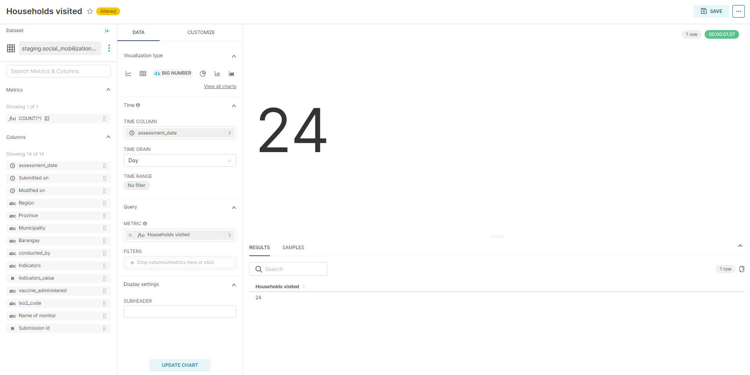

*Fig. Sample Big Number*

In the **Data** section, you can define the following:

* **Metric:** These can be previously created values in your table. You can also create a simple metric on the simple tab, or you can create the metric in Custom SQL. When you are creating a simple metric, you can select the column/field name you want to use, and the aggregate value (COUNT, COUNT DISTINCT, AVERAGE, SUM, MAXIMUM, or MINIMUM). You can also give the metric a unique name by clicking the pencil (edit) icon next to “My Metric”. When you are done with the metric, click save to save changes or close to discard any changes you made.
* **Filters:** Add the specific data fields for desired chart filters.

There are also other chart options:

* **Subheader:** This is a description text that will appear below the big number.
* **Number format:** This option defines the numeric display format.

##### Table chart

The table chart can be used to visualize data in a table format. While tables are useful, it is recommended to view them along with charts as users can analyze data more quickly using visual charts. You can define a time period for the chart data, but this will require defining a temporal data field/column.

###### Sample table

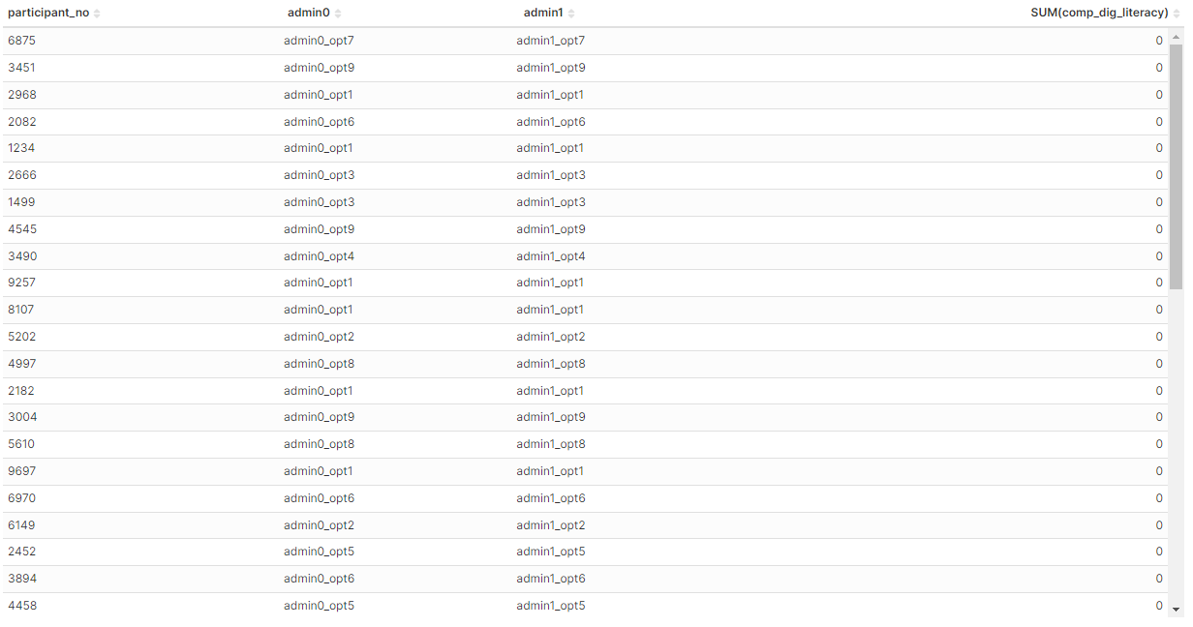

You can create tables by grouping or not grouping. Use the **Aggregate** if you want a query that aggregates. Use the **Raw Records** if you want to query individual rows.

In the **Aggregate** section, you can include the following:

* **Dimension:** This option defines how you want to group the data displayed in the table.
* **Metric:** These can be previously created values in your table. You can also create a simple metric on the simple tab, or you can create the metric in Custom SQL. When you are creating a simple metric, you can select the column/field name you want to use, and the aggregate value (COUNT, COUNT DISTINCT, AVERAGE, SUM, MAXIMUM, or MINIMUM). You can also give the metric a unique name by clicking the pencil (edit) icon next to “My Metric”. When you are done with the metric, click save to save changes or close to discard any changes you made.
* **Percentage Metric:** These will be defined similarly to the Metric, but displayed as a percentage rather than as a numeric value.
* **Sort by:** This option defines the metric that will be used to determine which value is the top series.
* **Sort descending:** If this option is selected, the data will be sorted descending. Otherwise, it will be sorted ascending.
* **Include time:** This option defines whether to include the time granularity as defined in the time section.
* **Row limit:** You can change the number of data values that can be visualized in a chart.

In the **Raw Records** section, you can include the following:

* **Columns:** The option defines the column that will be displayed in the table.
* **Ordering:** This option defines the metric that will be displayed in the table.
* **Row limit:** You can change the number of data values that can be visualized in a chart.

###### Styling

Additional styling options available with the Table chart include:

* **Table Timestamp Format:** This option defines timestamp format.
* **Page Length:** This defines the number of rows per page. Zero means no pagination.
* **Search Box:** If this option is selected, the client side is provided with a search box.
* **Align + / -:** This option defines whether to align the background chart with +/- values.
* **Color + / -:** This option defines whether to color +/- values

##### Pivot table

The pivot view can be used to visualize data in a table format and easily transform rows into columns and vice versa.

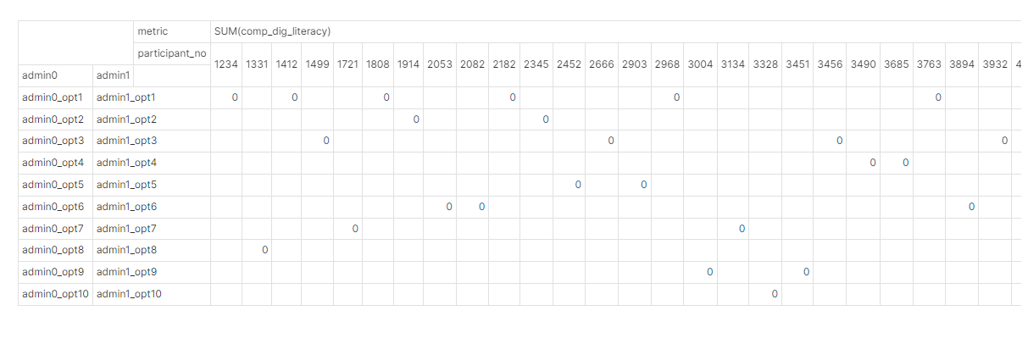

*Fig. Sample pivot table*

While tables are useful, it is recommended to view them along with charts as users can analyze data more quickly using visual charts. You can define a time period for the chart data, but this will require defining a temporal data field/column.

In the Query, you can define the following:

* **Metric:** These can be previously created values in your table. You can create a simple metric on the simple tab, or you can create the metric in Custom SQL. When you are creating a simple metric, you can select the column/field name you want to use, and the aggregate value (COUNT, COUNT DISTINCT, AVERAGE, SUM, MAXIMUM, or MINIMUM). You can also give the metric a unique name by clicking the pencil (edit) icon next to “My Metric”. When you are done with the metric, click save to save changes or close to discard any changes you made.
* **Filters:** Add the specific data field for the desired chart filters.
* **Dimension:** This option defines how you want to group the data displayed in the table.
* **Columns:** This option allows you to define what control you want to pivot to columns.
* **Row limit:** You can change the number of data values that can be visualized in a chart.

There are also pivot options:

* **Aggregation Function:** This option defines the function used when pivoting and computing the total number of rows and columns
* **Number Format:** This option defines the numeric format.
* **Display totals:** If this option is selected, the total rows/columns will be displayed.
* **Combine Metric:** This option defines whether to display metrics side-by-side in the table, as opposed to each column being displayed side-by-side for each metric

##### Country map

The country map allows you to plot choropleth maps of your country using the admin 2 boundaries. Before creating a country map, you need to:

* Confirm whether your country exists within the Superset lists of available maps.
* You need to add the ISO codes of the admin 2 hierarchy to your dataset.

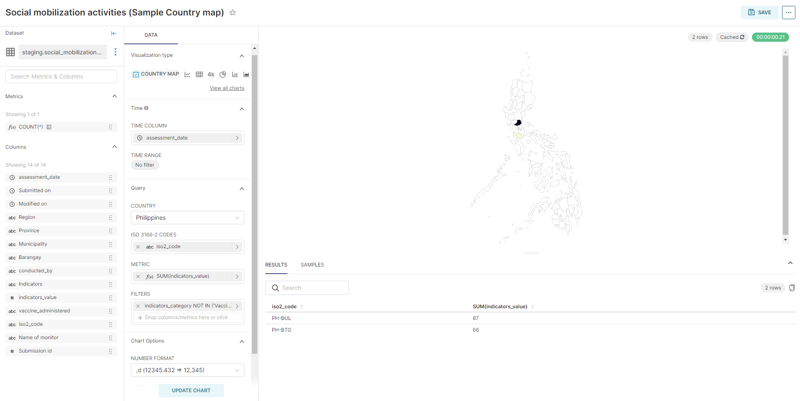

*Fig: Sample country map*

In the Query, you can define the following:

* **Country**: This is the name of the country you are visualizing with data.
* **ISO 3166-2 CODES:** The column with the admin 2 ISO codes.
* **Metric:** These can be previously created values in your table. You can create a simple metric on the simple tab, or you can create the metric in Custom SQL. When you are creating a simple metric, you can select the column/field name you want to use, and the aggregate value (COUNT, COUNT DISTINCT, AVERAGE, SUM, MAXIMUM, or MINIMUM). You can also give the metric a unique name by clicking the pencil (edit) icon next to “My Metric”. When you are done with the metric, click save to save changes or close to discard any changes you made.
* **Filters:** Add the specific data fields for the desired chart filter.

In the Chart Options section, you can define:

* **Number Format:** This option defines the numeric format.
* **Linear Color Scheme:** The color palettes that can be used on the map.

##### Deck.gl scatter plot

The deck.gl scatter plot allows you to map point data (data with latitude and longitude values).

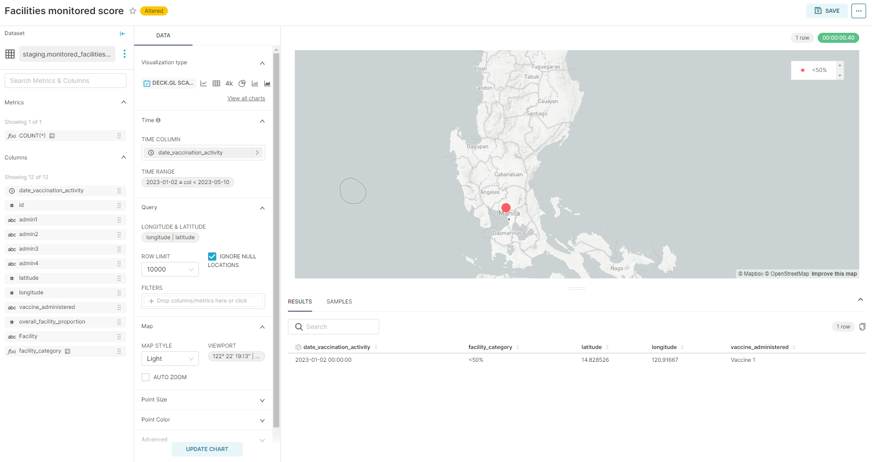

In the Query section, you will need to define:

* **Longitude&Latitude:** This option allows you to select the longitude and latitude values.
* **Filters:** Add the specific data fields for the desired chart filters.

In the Map section, you can define:

* **Map style:** This option allows you to customize the map display.
* **Point size:** This option allows you to define the size of the points
* **Point color:** This option allows you to define the color of the points.

#### Save a chart

Once you have finished your chart, you can save the chart by clicking on **Save,** in the upper right corner.

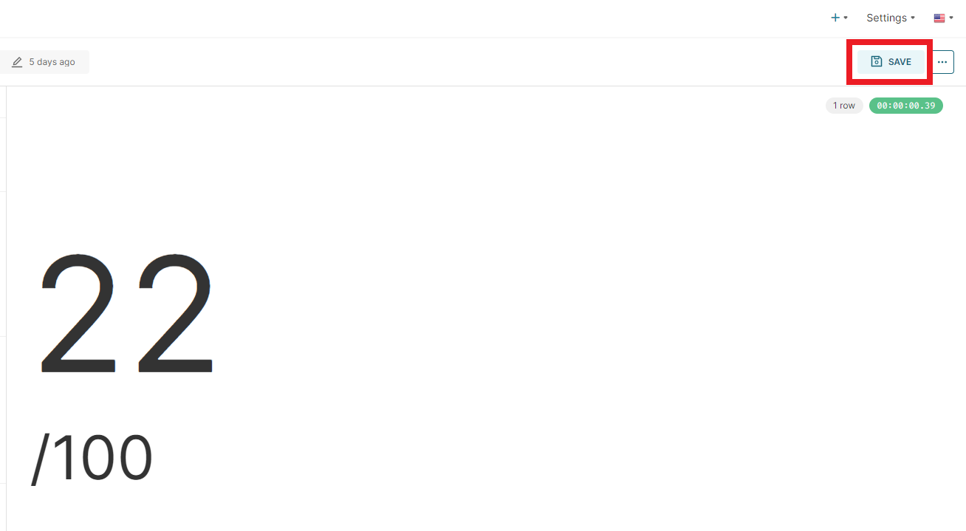

Then, a pop-up will appear to Save a Chart. You can either overwrite an existing chart or save it with a new chart title. Then, type the name of the chart in the text box under the **Chart Name**. The second selection is where you want the chart to be added. You can add the chart to an existing dashboard or create a new dashboard by typing it in the textbox.

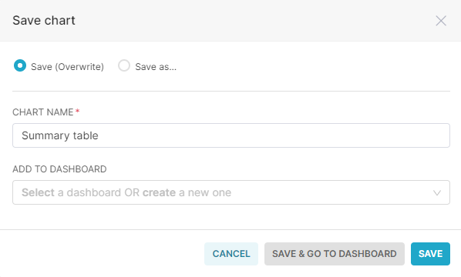

### Dashboard

Once you have created at least one chart, you can begin to develop your dashboard. You can either develop all of your charts and then build the dashboard or build the dashboard as you create charts. If you have already created your dashboard or would like to create a dashboard, you can do this from the dashboard tab.

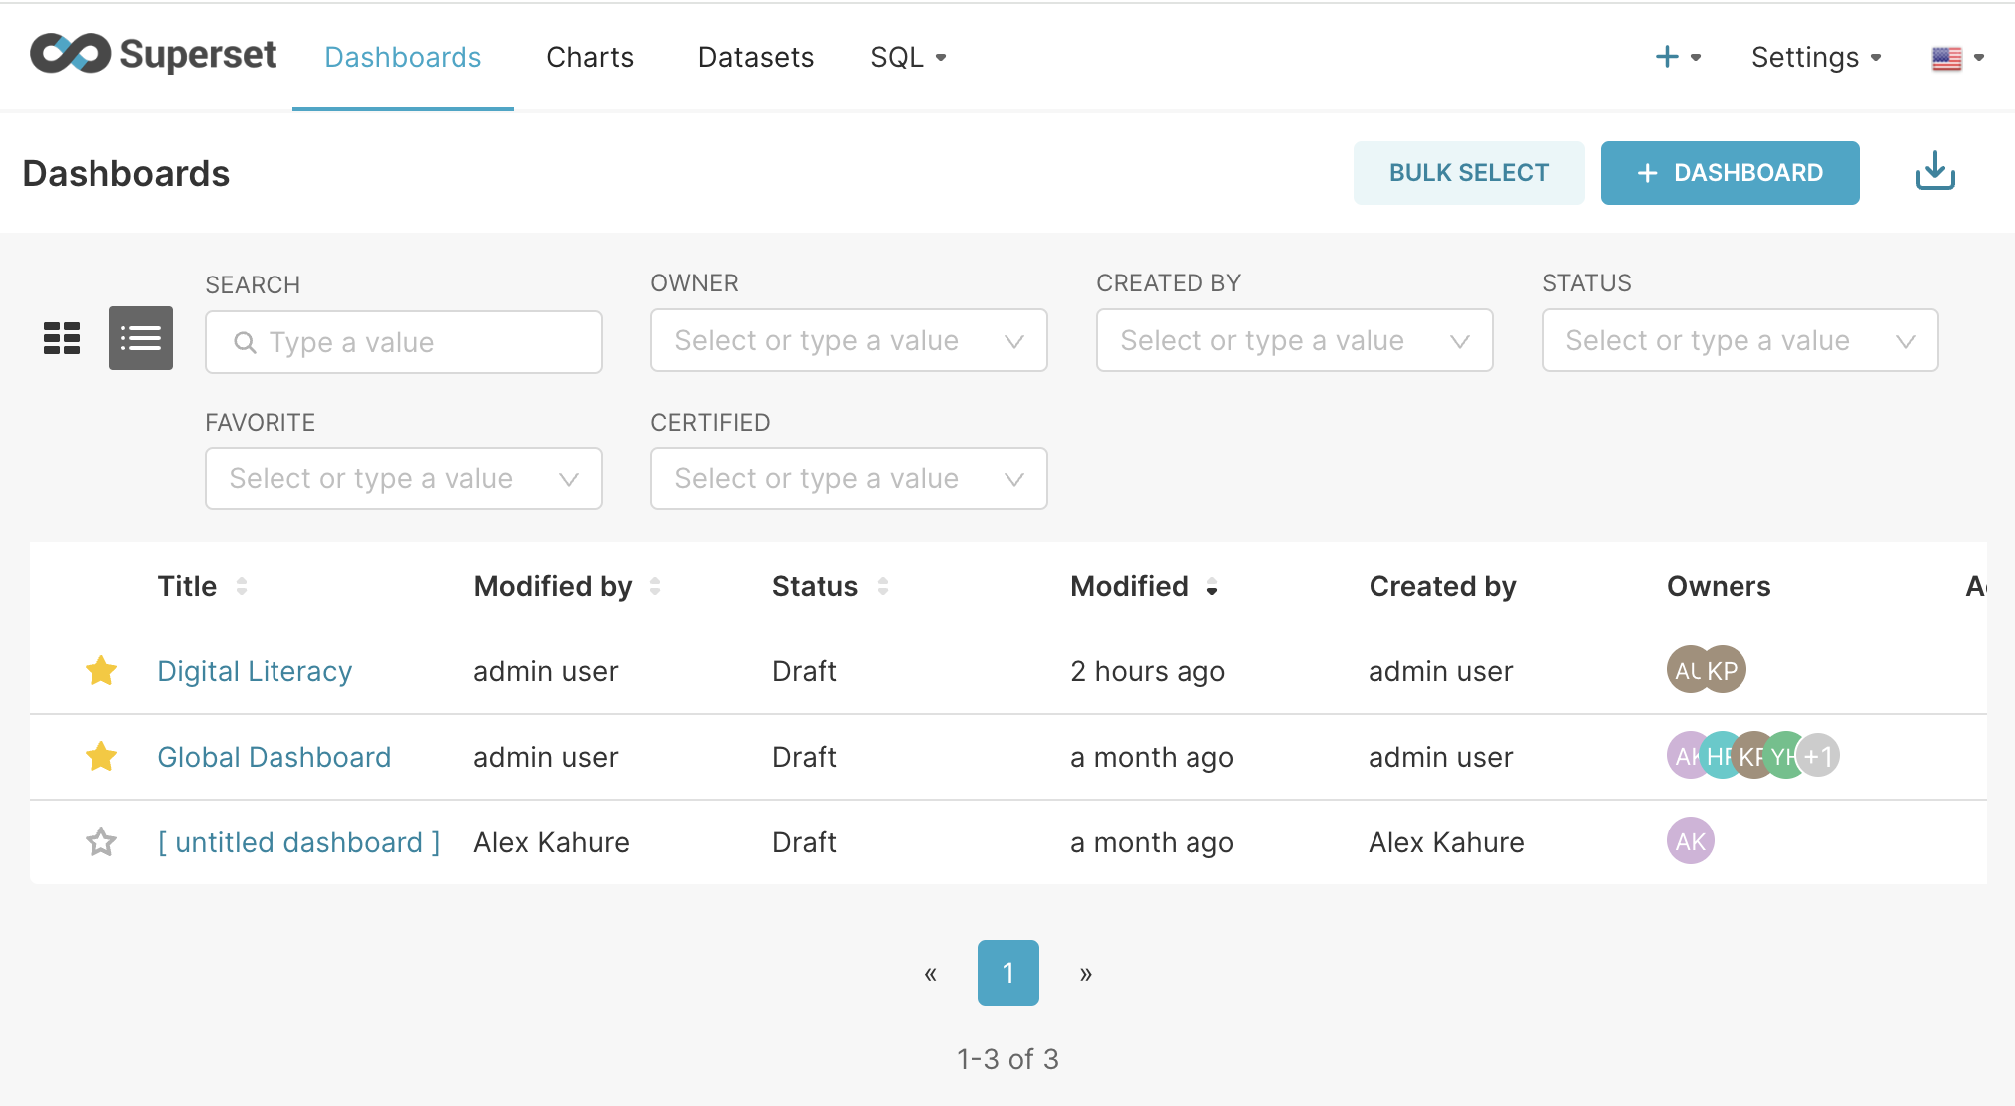

To find the dashboard, you can filter by Name, Owner, Created By, Status, Favorite, or Certified.

#### Creating your dashboard

You can create a new dashboard by selecting the + **Dashboard** button in the top right corner.

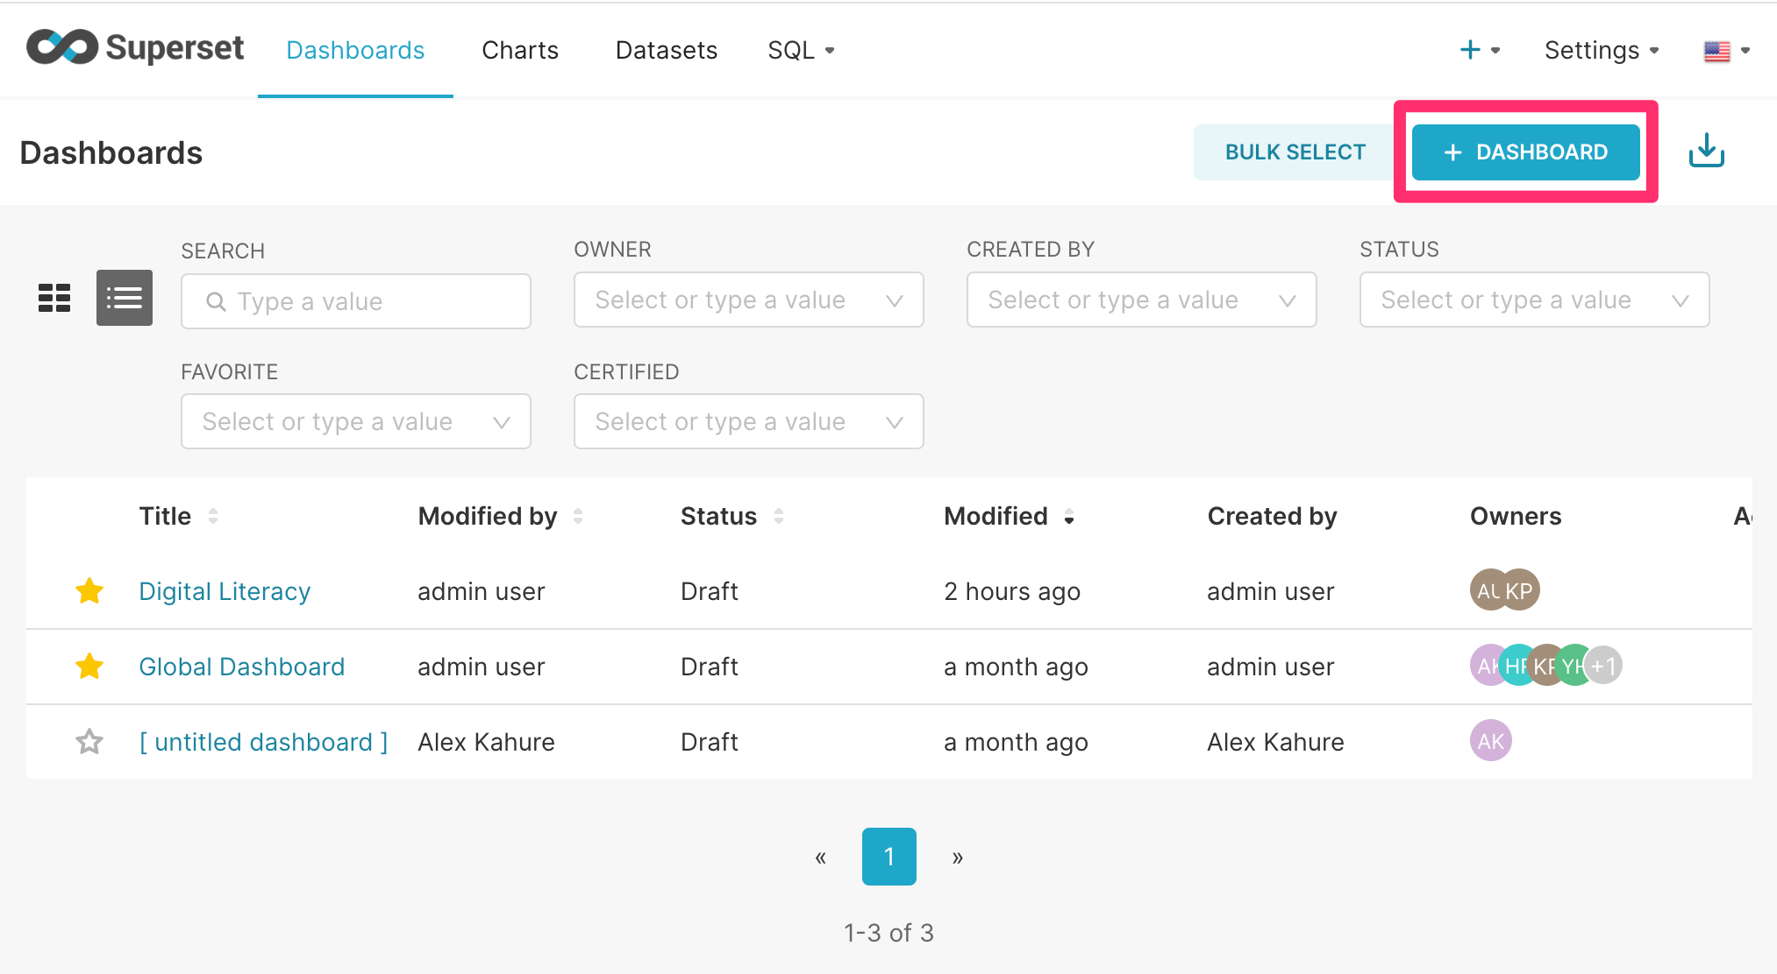

After adding a new dashboard, the Add Dashboard page appears.

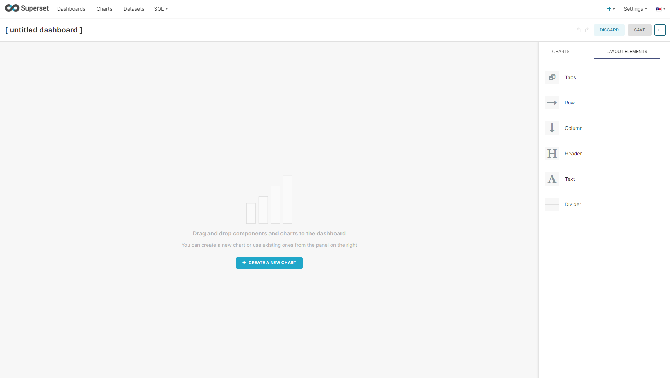

All the components to build the dashboard will appear under the layout elements.

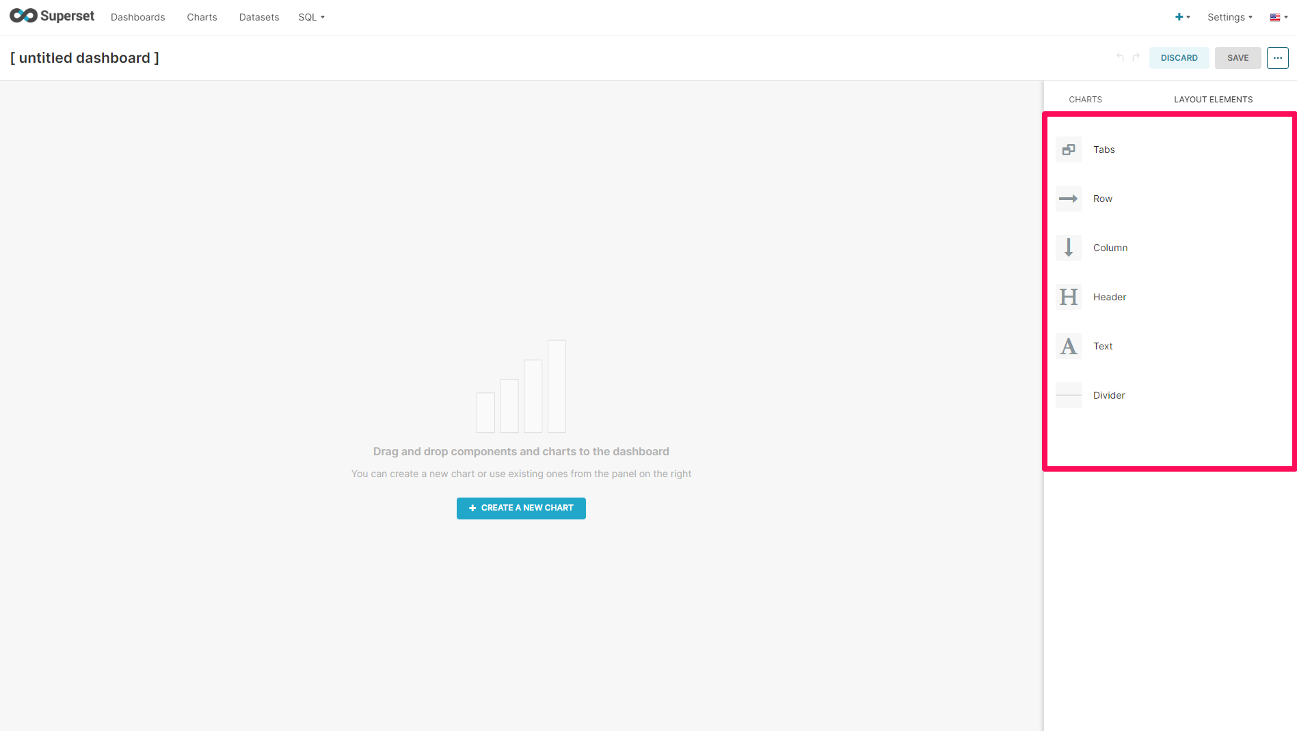

##### Tabs

If you are creating many charts for your dashboard, you will probably want to break up the dashboard into tabs by grouping similar chart content on the same tab.

To add tabs, you should:

1. Click **Tabs,** in the right side panel, and drag until a blue line appears, indicating you can drop the tab there. For an empty dashboard, an additional line will appear at the very top, where the gray background begins.
2. One tab will appear in the placed Tabs location. To add more tabs, click the plus ( + ) icon.

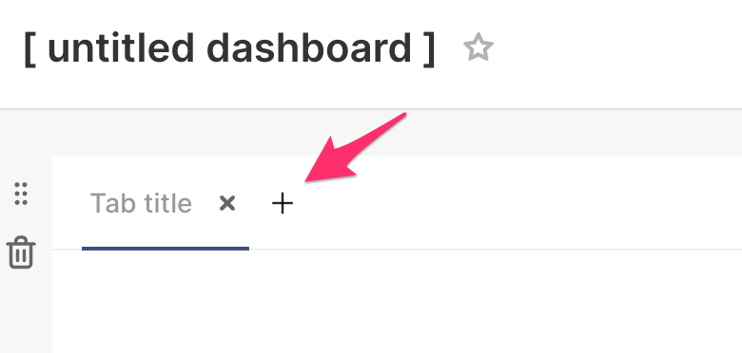

1. To rename the tab, double-click the **Tab title,** and a text box should appear to rename the tab. In the example below, the tab was renamed to “Tab 1”.

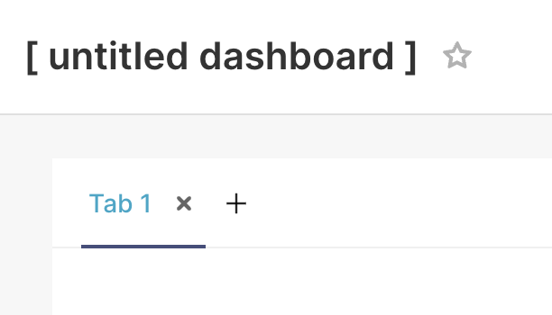

##### Row/Column

You will want to add a column or row. We recommend starting with a row. Click **Row**, and drop and drag to the same level where the first row of tab labels appear for the first row and below for other rows. Use the blue line to guide where the row will appear.

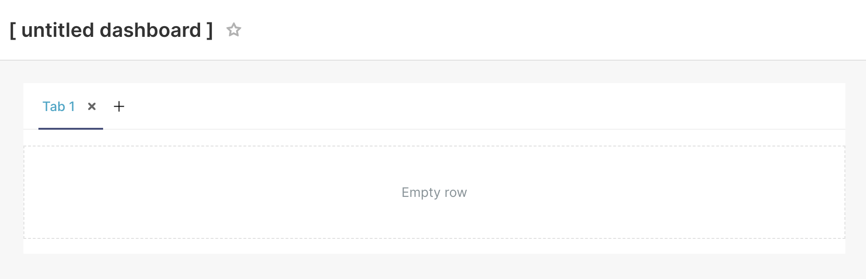

##### Adding charts

You can easily add charts at this point. Click **Charts,** and a list of all charts will appear, starting with the most recent charts and filtered with the default sort by the most recent. You can change how the charts and filters are filtered by clicking the drop-down. You can also search for a specific chart in the search box.

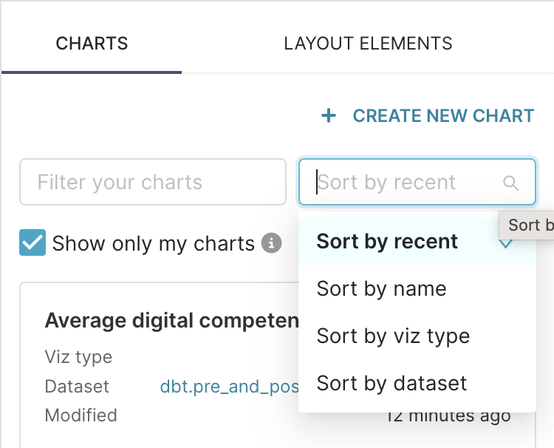

Once you find your chart or filter, you drag and drop it to the location on the dashboard. Once you drop it in the correct row/column, you will most likely want to resize the chart. To do this, click the icon in the lower right corner of the chart and size it as desired by dragging it to the left or right and up and down.

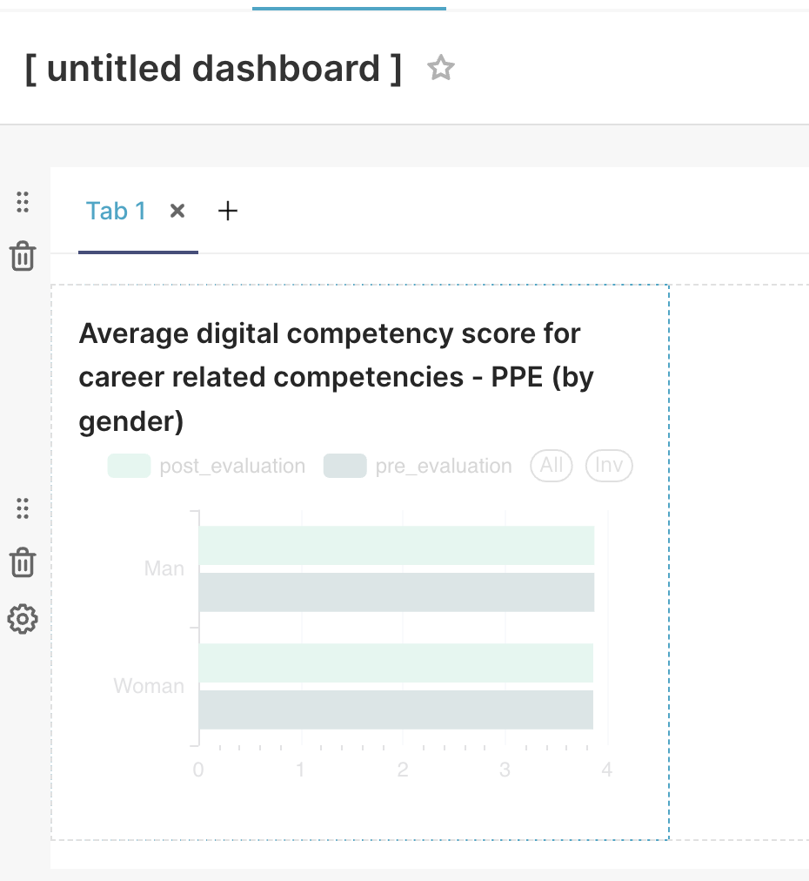

##### Headers

Once you have added your charts in the correct location and resized them accordingly, you may want to add additional headers to break up the dashboard tabs. To add a header, drop and drag **Headers** to the desired location.

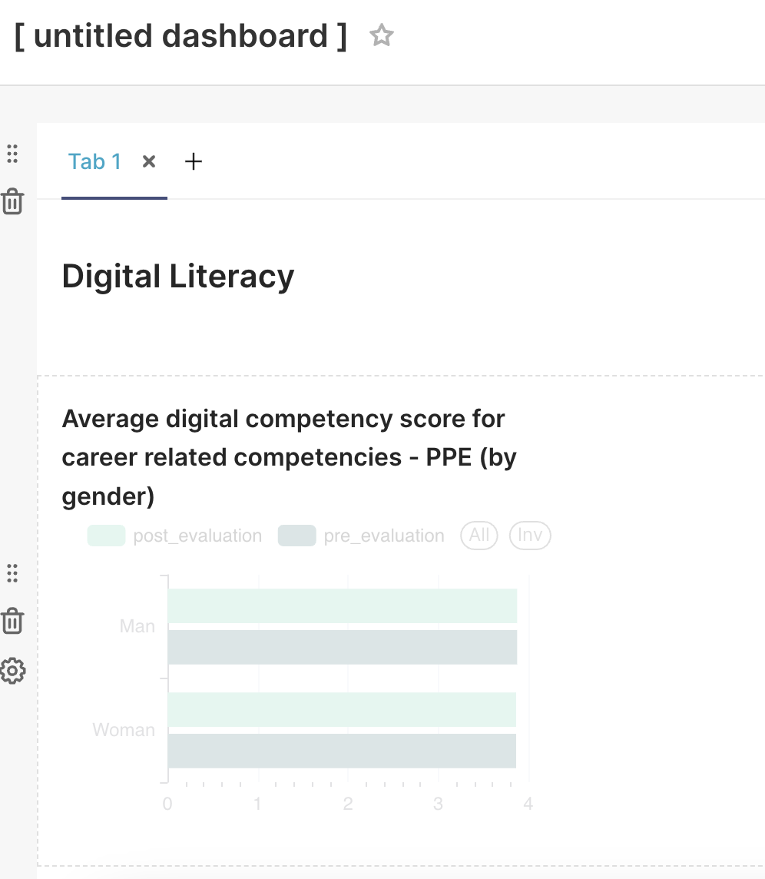

##### Dividers

Once you have added your charts in the correct location and resized them accordingly, you may want to add additional dividers to break up the dashboard tabs. To add a divider, drop and drag **Dividers** to the desired location.

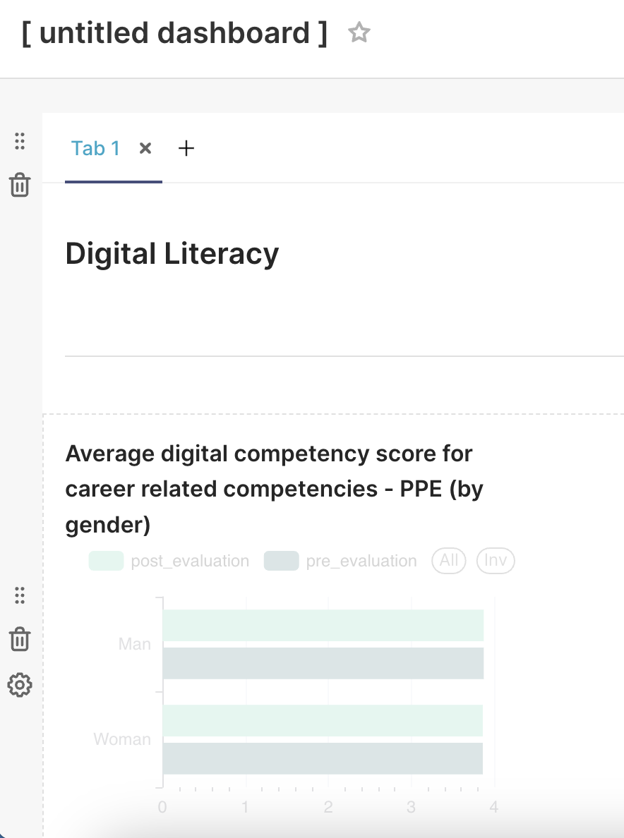

##### Delete a dashboard component

If you accidentally add a chart and want to delete it, in edit mode, click the chart and a trash icon will appear. Click the trash icon to delete the chart.

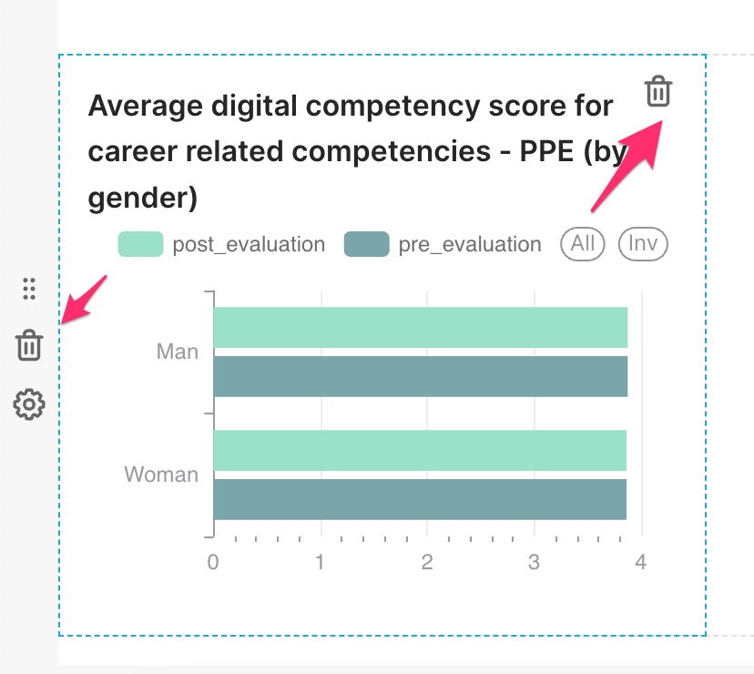

##### Save the dashboard

Once you have finished creating your dashboard, click **Save.** This will automatically switch to view mode.

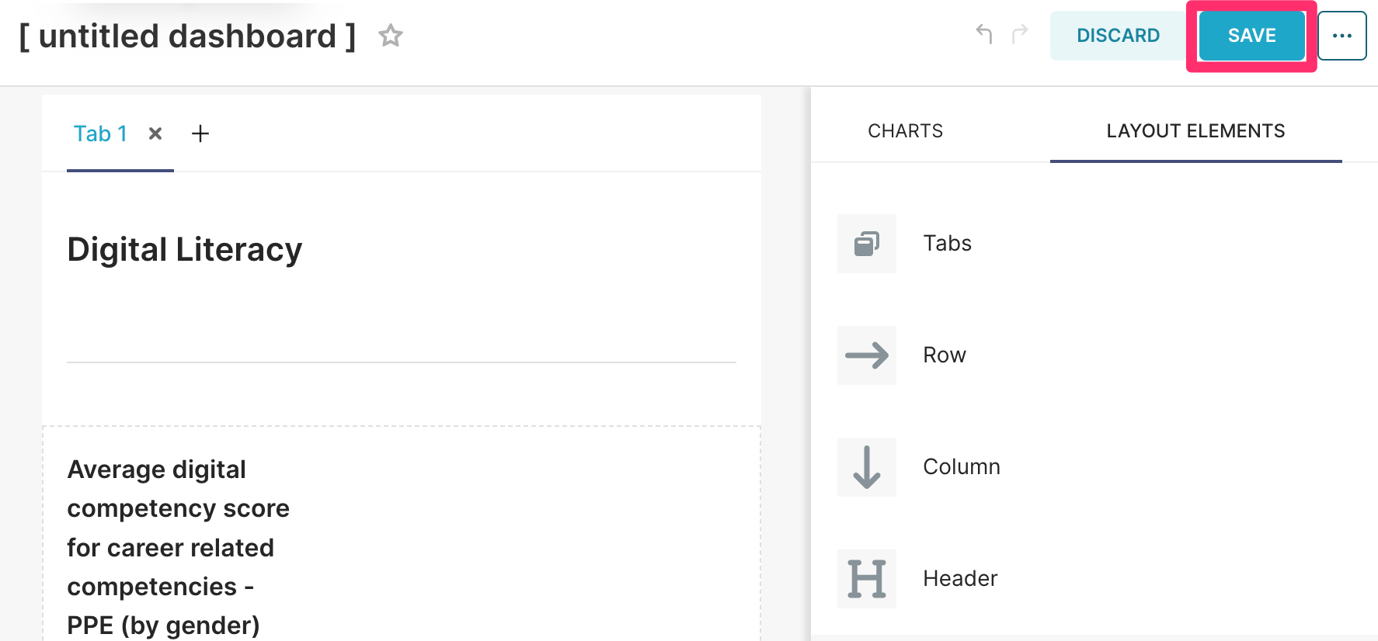

##### Add/Edit Dashboard Filters

You may want to add filters to your dashboard to filter data in the charts. However, charts can only be filtered if the data field used to filter is a column in the same data source used to create the chart.

To add/edit a choice filter, you need to:

1. Open your saved dashboard and open the expandable window on the left.

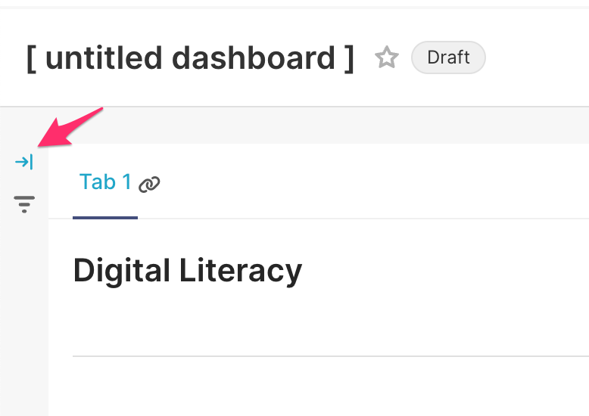

1. Click **Add/Edit Filters**, which opens a pop-up window to define the filter.

###### Filter Settings and Scoping

The filter settings allow you to define your filter:

* **Filter type** defines the type of filter (i.e. Value, Numerical range, Time).
* **Filter name** defines the name of the filter.
* **Dataset** defines the data source used for the filter.
* **Column** defines the data field used to filter the data.

There are also filter configurations (depending on the filter type selected) and settings to allow you to customize the filter.

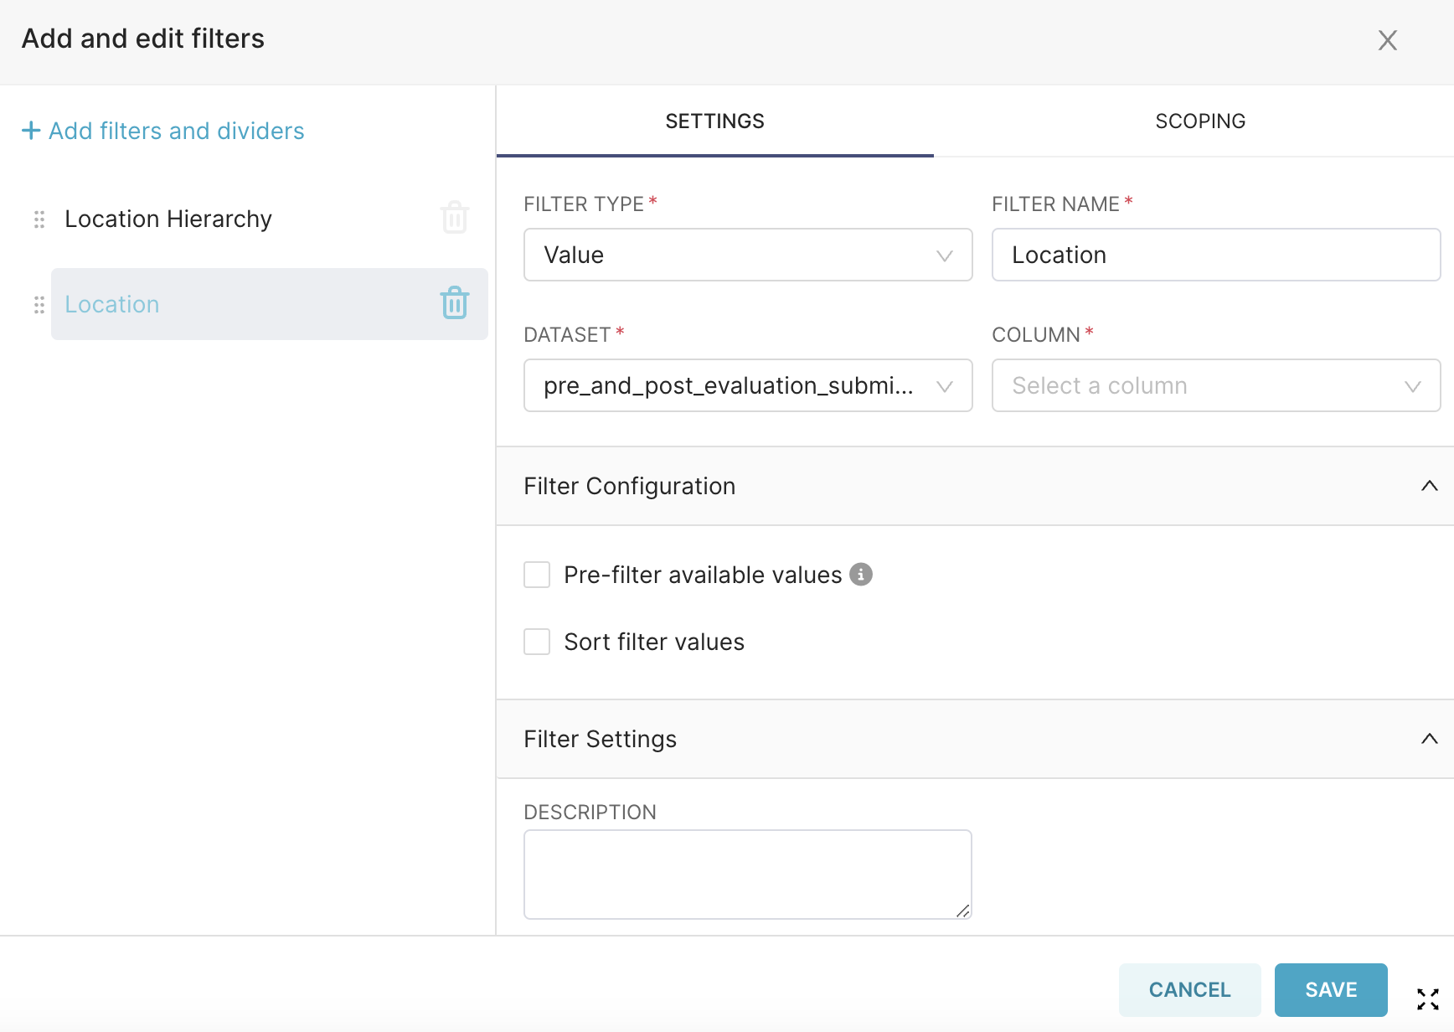

The filter scoping allows you to define where the filters are applied: to all panels or specified panels.

You can also add a divider between filters.

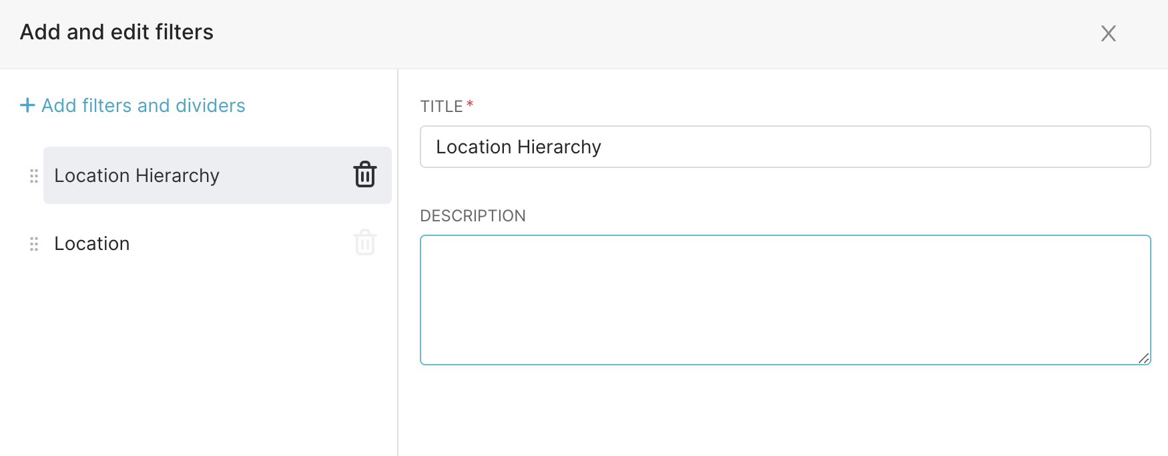

You can add more filters/dividers by clicking **+ Add filters and dividers**. You can move the filters and dividers around by dropping and dragging the filter and divider components on the left. Delete the filter/divider by selecting the trash can icon next to the components. Click **Save** to finalize changes.

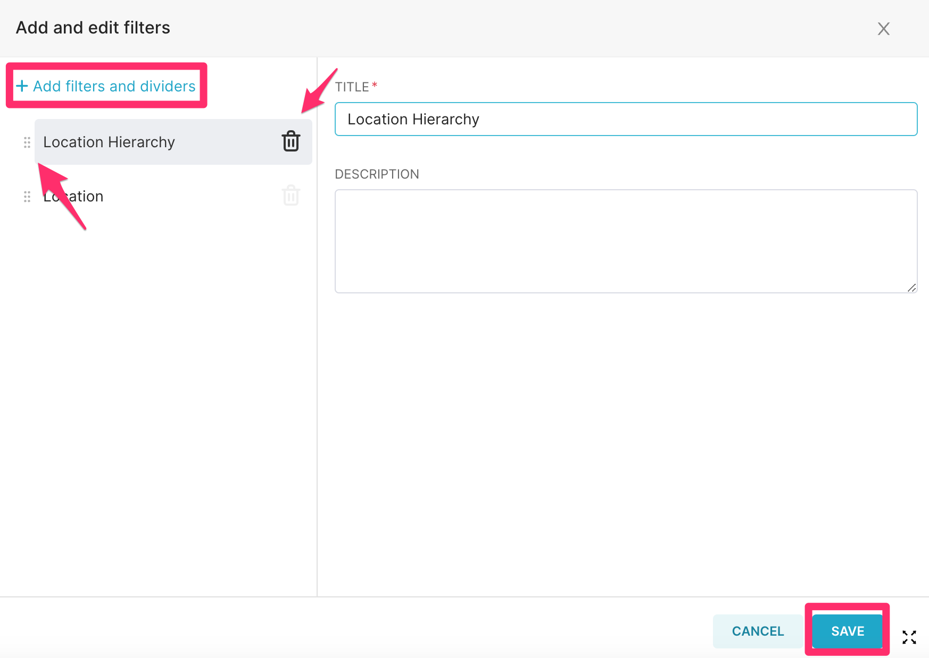

##### Dashboard actions

From the **Dashboards** page, dashboards can also be viewed by clicking on the title of the dashboard. There are other actions you can perform on the dashboard, as shown in the Actions column in the screenshot below:

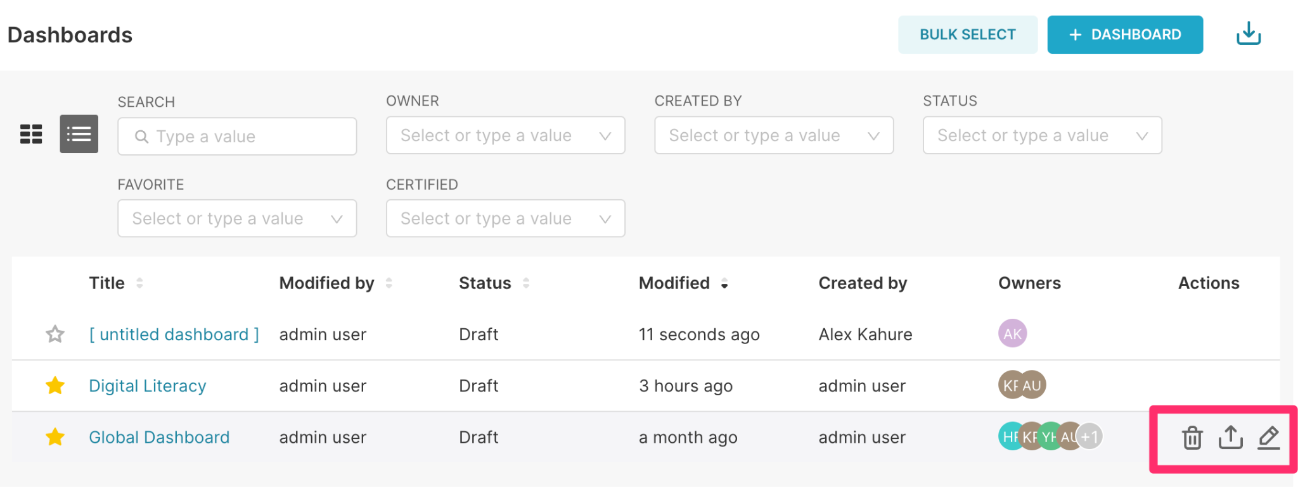

* **Delete (first icon)**: Allows you to delete the dashboard. If you select delete, you will have to confirm your selection in a popup window. Select **OK** to delete the dashboard, and select **Cancel** to not delete the dashboard.
* **Export (second icon):** Allows you to export the dashboard in .json format.
* **Edit (third icon):** Allows you to edit the dashboard properties.

##### Dashboard properties

You can edit the following dashboard properties:

* **Title:** Enter the name of the dashboard
* **URL Slug:** You can ignore this field. This field is intended for readable URLs to associate with your dashboard
* **Owner:** Add yourself and anyone else who should be the owner of the dashboard. Please note that the person must have an account before they can be added as an owner.
* **Colors:** You can select a color scheme for your dashboard. Once you select the color scheme of your choice, this will also be populated on the JSON Metadata
* **JSON Metadata (Under Advanced):** This JSON object is generated dynamically when clicking the save or overwrite button in the dashboard view.

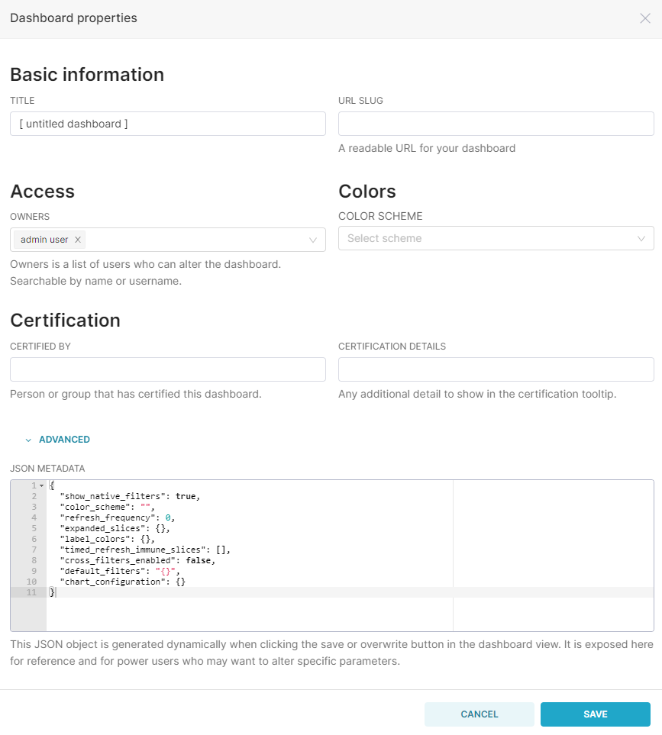

**NOTE**: Make sure to click **Save** before exiting to make sure all edits are saved.

##### Additional features

###### Choose the color for a variable

If you would like to force a variable to be a specific value, such as blue for disaggregation of total vaccinated in a chart, you will need to edit the dashboard information. In the JSON metadata, scroll to the bottom of the text. Add the following text before the curly bracket and last line of text.

"label_colors": {

"Total vaccinated": "#1CABE2",

"Total refused": "#FFC20E"

}

where **Total vaccinated** and **Total refused** are metrics in the charts. The colors are based on the Hex color code. Examples include:

● Red is #E2231A

● Orange is #F26A21

● Yellow is #FFC20E

● Green is #00833D

● Blue is #1CABE2

● Purple is #6A1E74

● Black is #000000

● White is #FFFFFF

● Gray is #777779

This [site](https://www.color-hex.com/) is a great place to search for the hex color code for a lot of colors if you want to use non-UNICEF colors.

#### SQL Lab

If you would like to view the content of the datasets or create a view/table, you can use the SQL Editor Lab to run the SQL scripts. To access the SQL Editor, hover over the **SQL** drop-down menu and click **SQL Lab**.

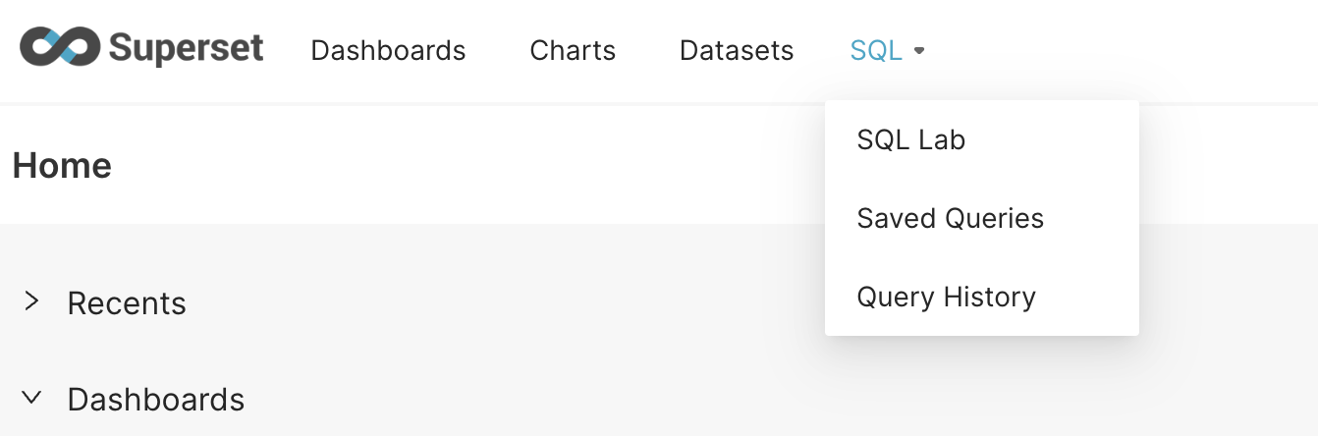

In the SQL Lab, you can select what you will be using to create your SQL query:

* **Database** - Select the database where the tables you will be using in the query are located.
* **Schema** - Most raw data is loaded in the inform schema. However, there may be other schemas as well. You can also select other schemas and see what data is saved there.
* **See Table Schema** - Select the table that you will be using in your query. This will allow you to see more information about the table variable values and provide a view of the data.

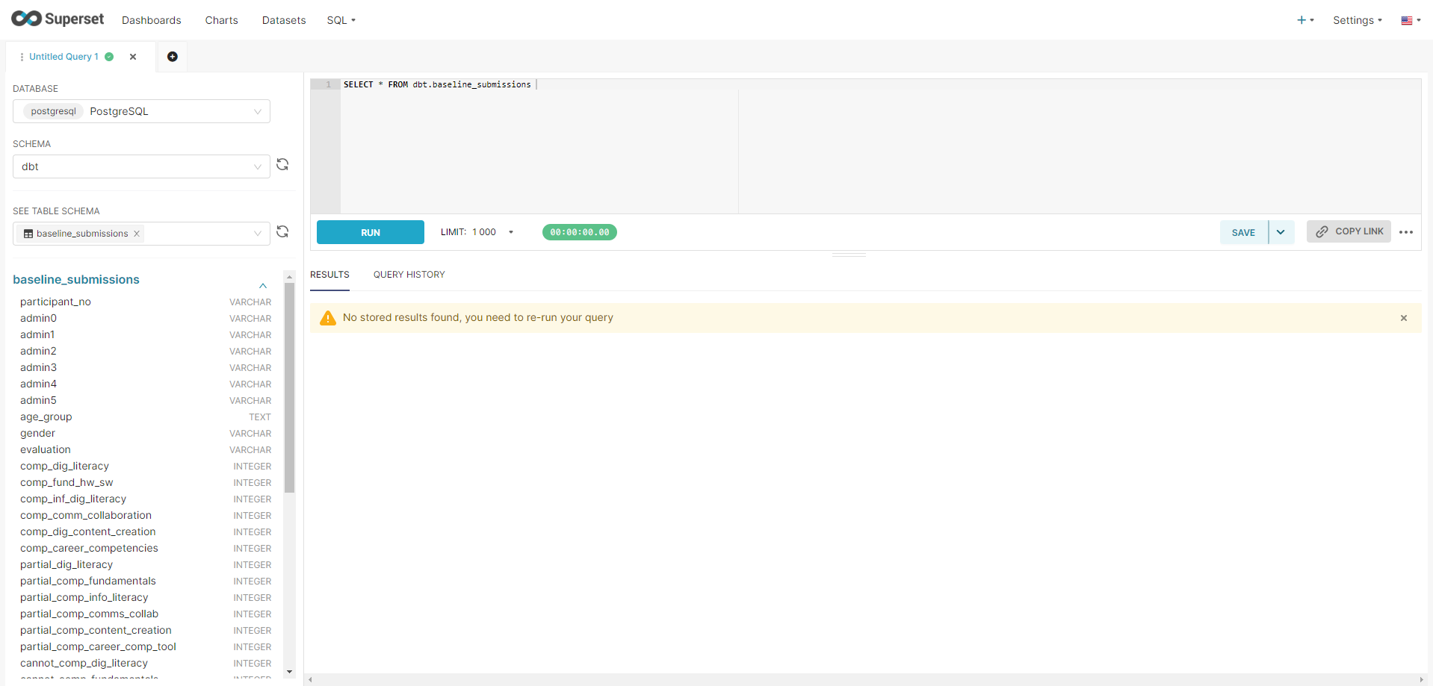

##### Table schema

Once you have selected the table schema, you can view more information about the table variable data types. This option is especially valuable when you want to understand why your SQL query may not be working as expected due to the type of variable.



You can also view the data as it appears in that table. Once you select the table, a tab will appear with the name of the table (as shown below).

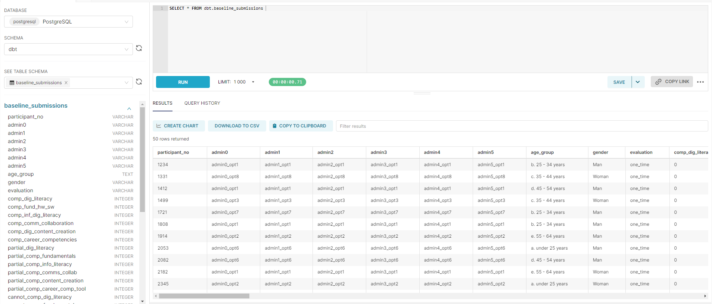

#### Custom SQL Query

Due to the complexity of the chart indicator, how the data appear in the table, or preference toward building indicators using SQL, you may prefer to generate all your charts using the SQL Editor. All queries that are saved in the **SQL Editor** will appear in the *Saved Queries* screen.

From there, you have access to a variety of features that enable you to manage and work with your saved queries, such as:

* View, edit, and delete saved queries
* Copy a URL for the saved query
* Bulk delete and export saved queries

##### Adding a Query

To create a new query, you click the blue plus sign (+) on the top right corner of the page and select **SQL query** (as shown below), or you can just create it in the window in SQL Lab Editor.

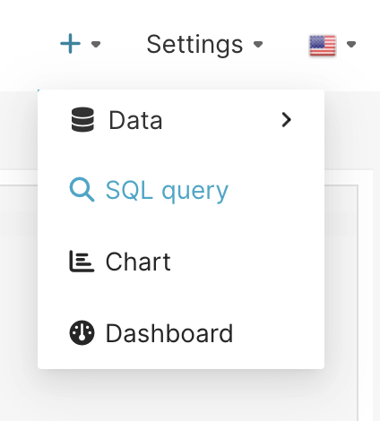

All queries must start with a SELECT and end with a FROM, but queries can have several SELECT statements nested according to your needs. If you encounter issues generating your desired indicator, we recommend working from the smallest innermost function of the indicator and working out for the indicator. For example, we recommend defining your query to generate all the required data and any additional variable requiring any additional calculation on our SELECT statements.

NOTE: This [site](https://www.w3schools.com/sql/) is very helpful in understanding how to use an SQL function to generate your desired query.

Queries can be written in the window with SELECT, FROM, WHERE as shown below in the red box. Once you have written the query, select **Run**.

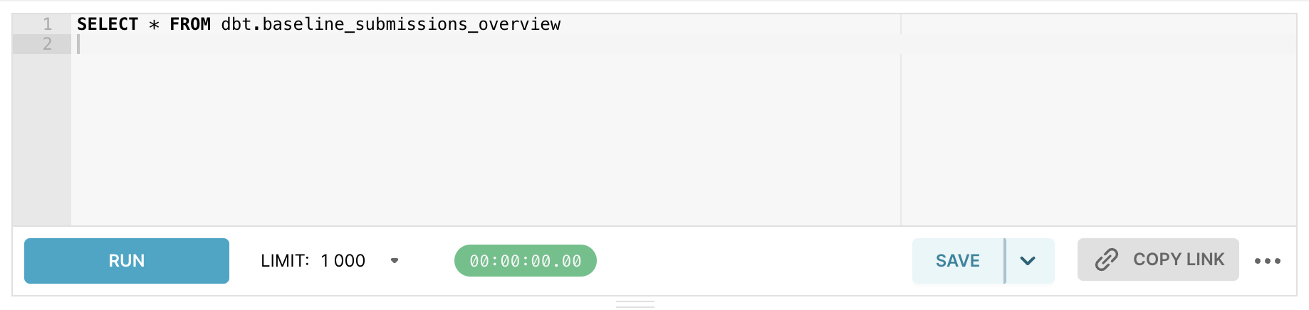

### Duplicate a Dashboard

It is easy to create a copy of a dashboard on Superset. All you need to do is:

1. Open the dashboard you want to copy from the Dashboard page
2. Click the three horizontal dots ( … ) and select **Save as**.
3. In the pop-up window, select **Save as**, enter the name of the copied dashboard, and select the checkbox for **also copy (duplicate) cha**r**ts**

